**DEPARTMENT OF COMPUTER SCIENCE & ENGINEERING SRINIVASA RAMANUJAN INSTITUTE OF TECHNOLOGY**

**Database Management systems Lab**

1. **Write SQL queries to CREATE TABLES for various databases using DDL commands (i.e. CREATE, ALTER, DROP, TRUNCATE).**

**CREATE:**

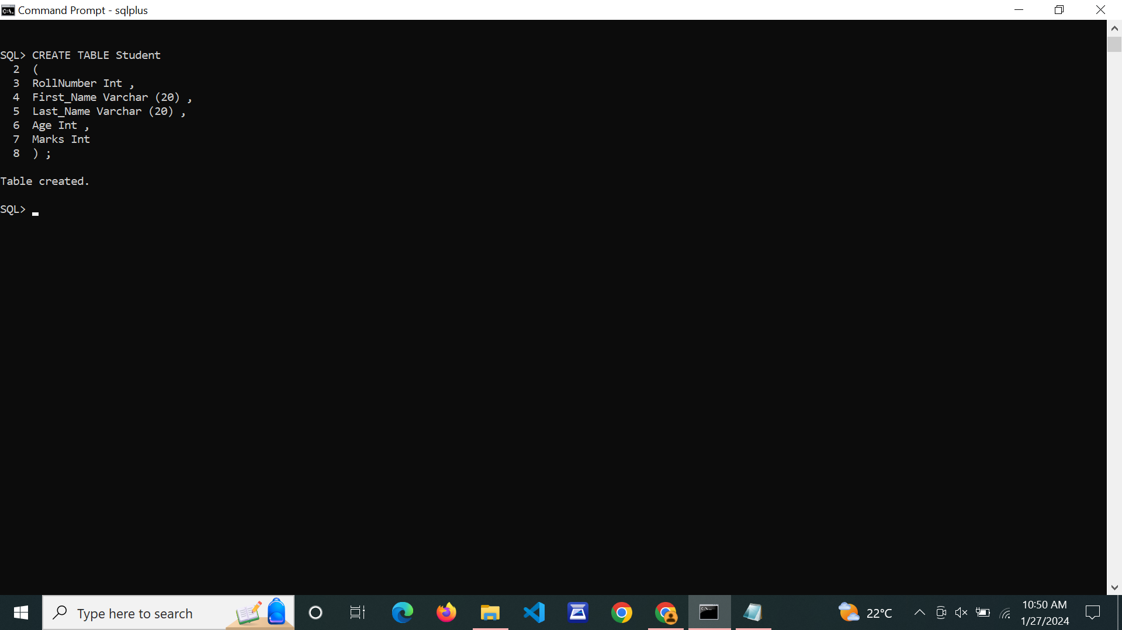

**ALTER:**

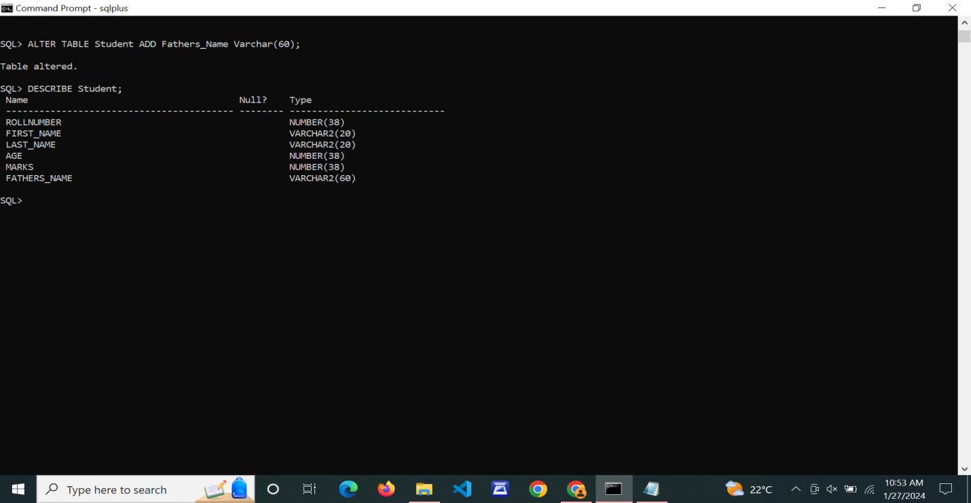

**DROP:** 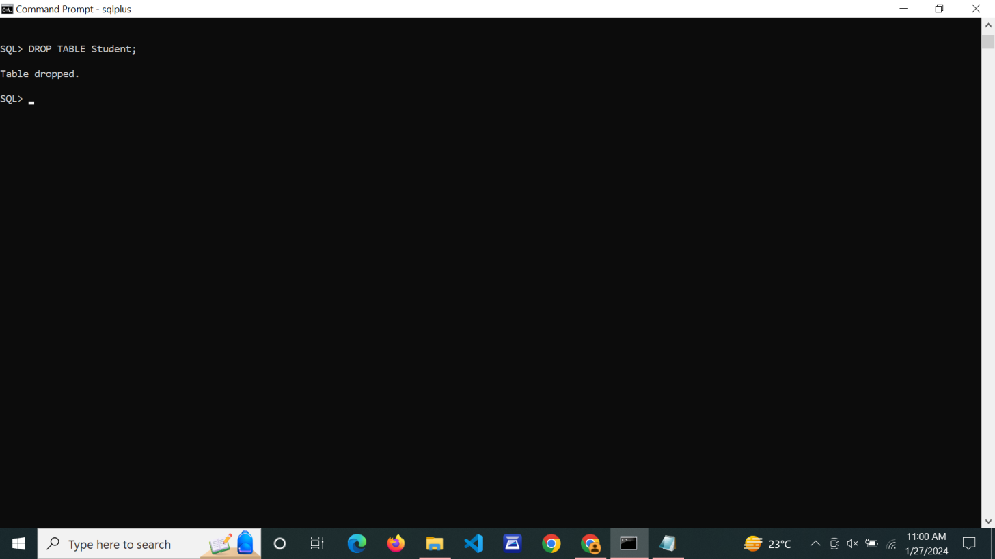

**TRUNCATE:**

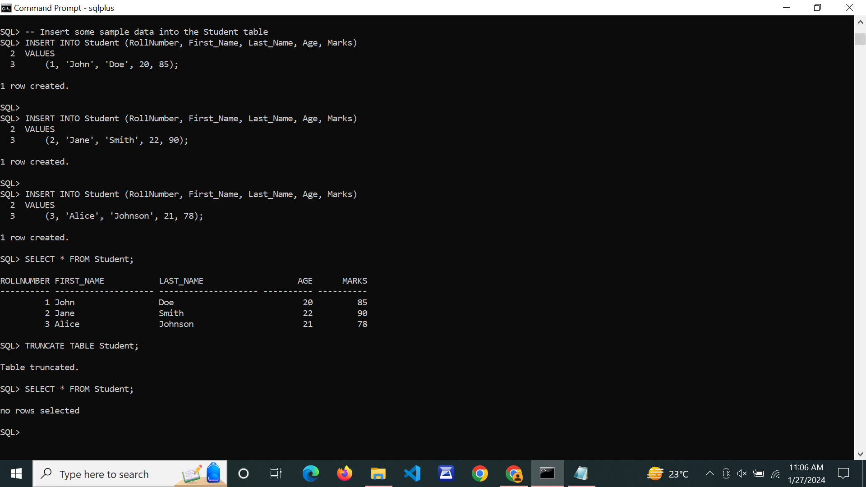

1. **Write SQL queries to MANIPULATE TABLES for various databases using DML commands (i.e. INSERT, SELECT, UPDATE, DELETE,).**

**INSERT:**

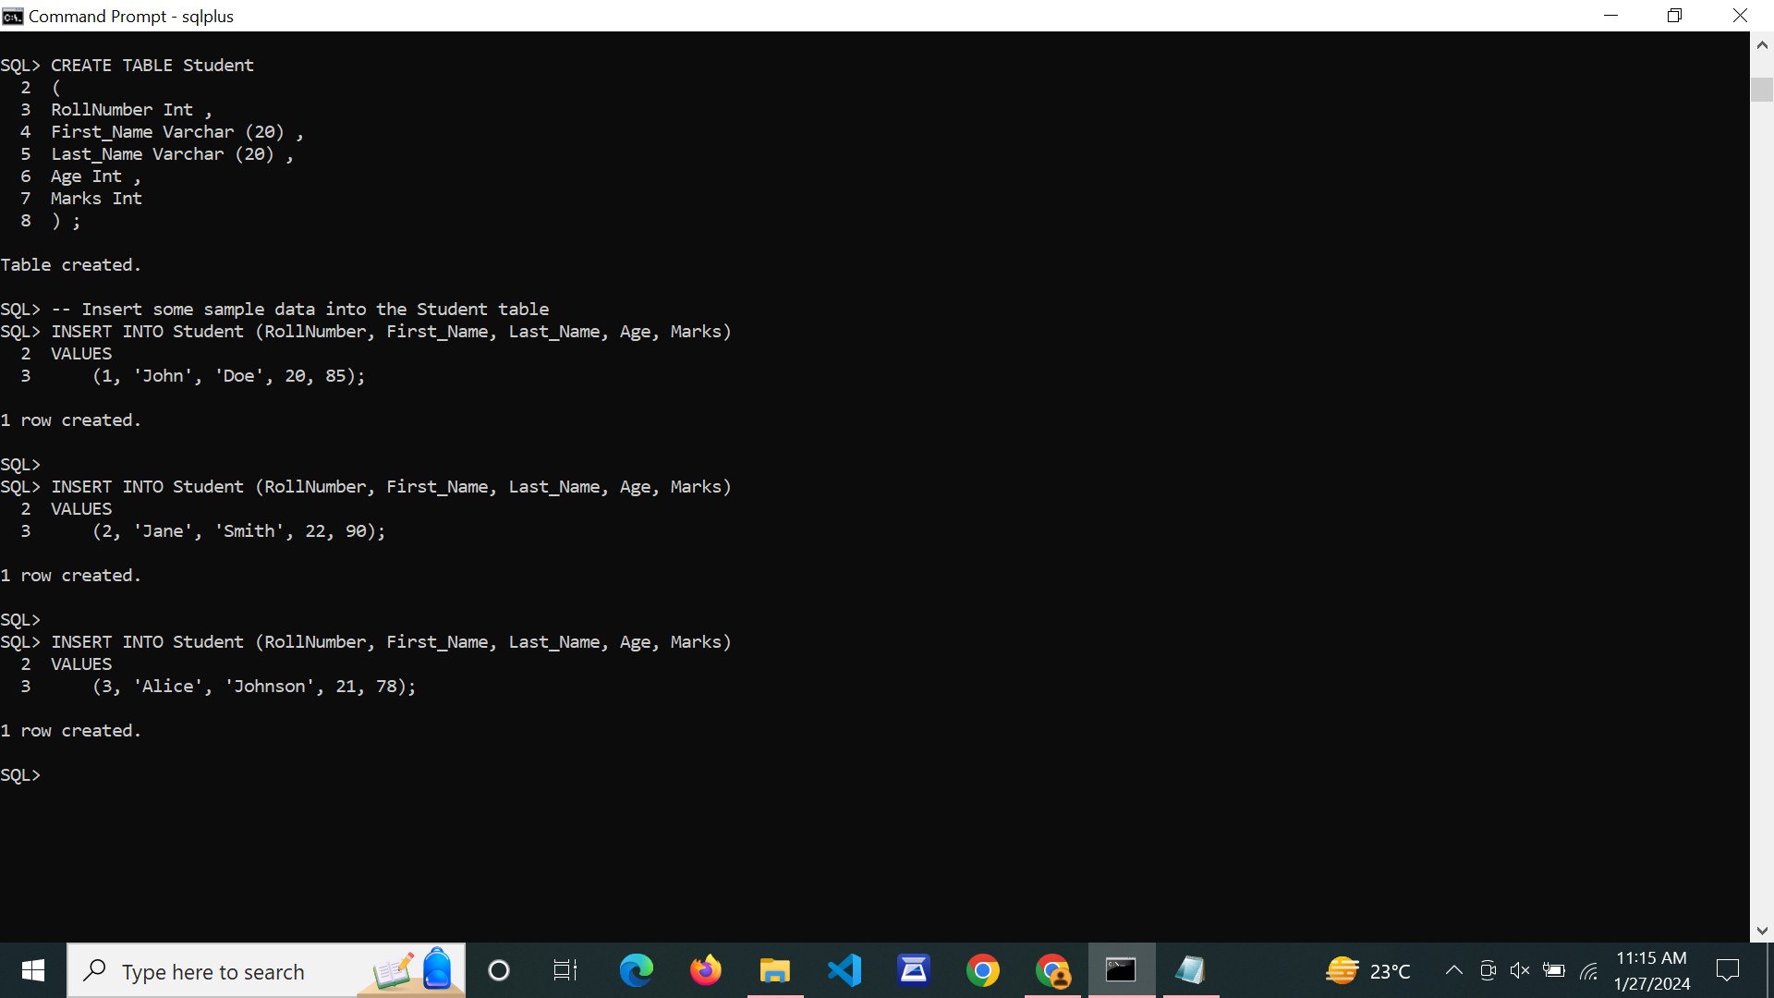

**SELECT:**

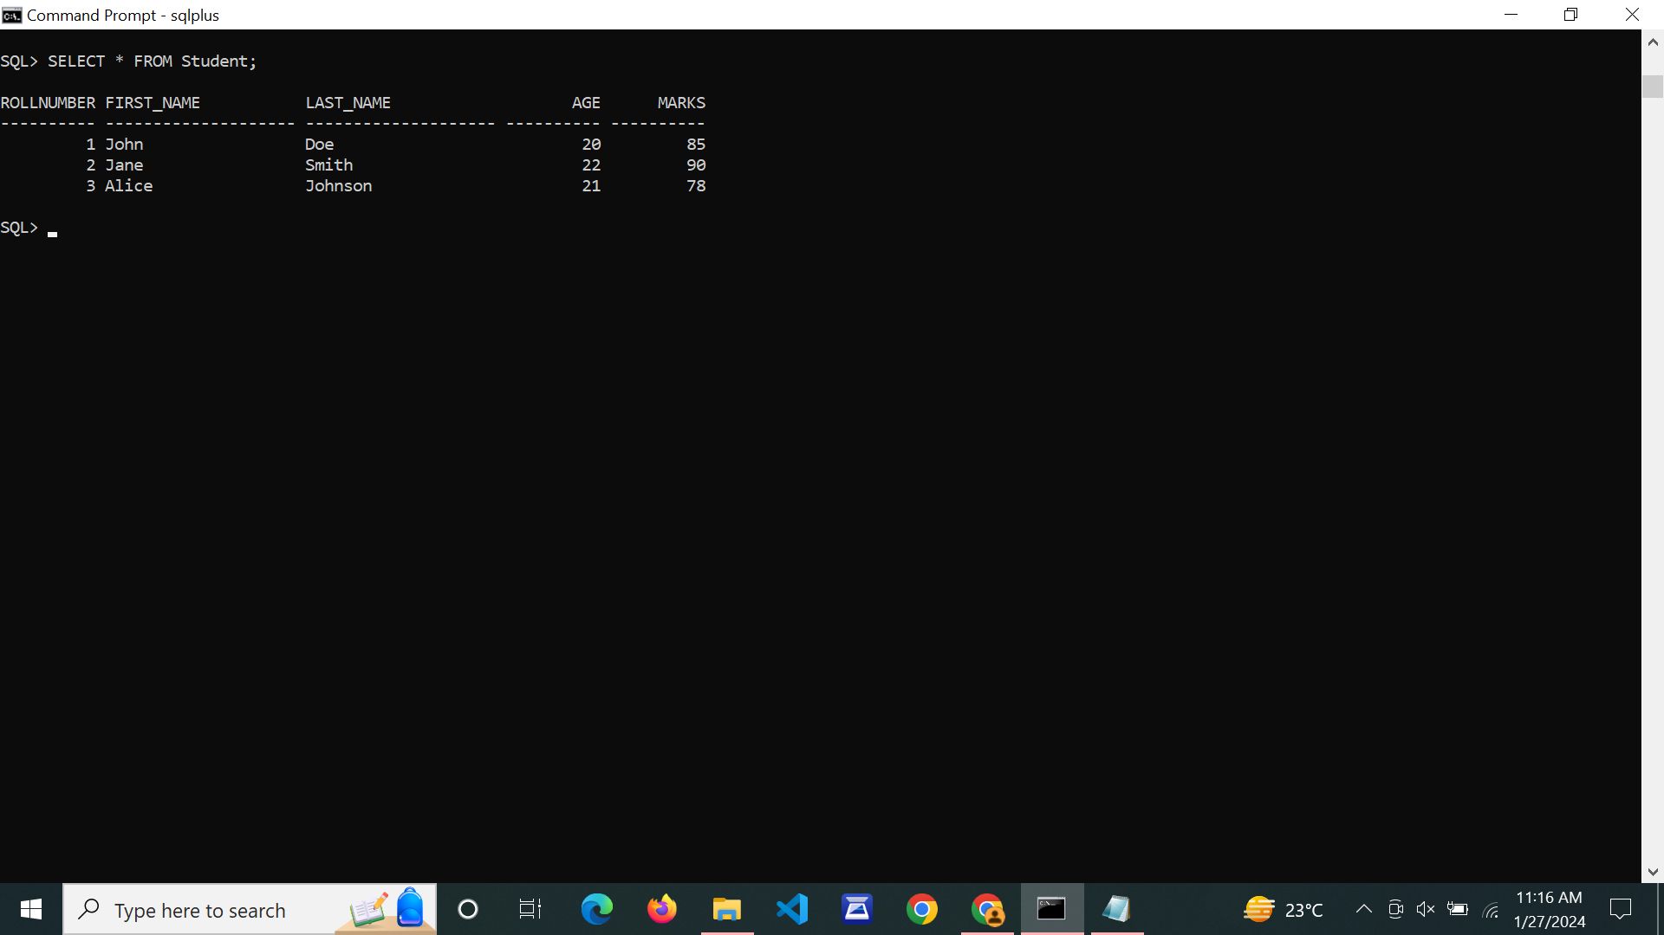

**UPDATE:**

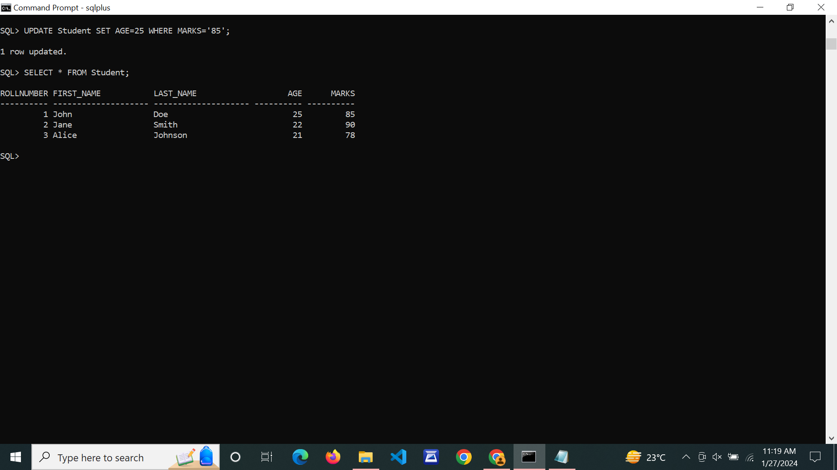

**DELETE:**

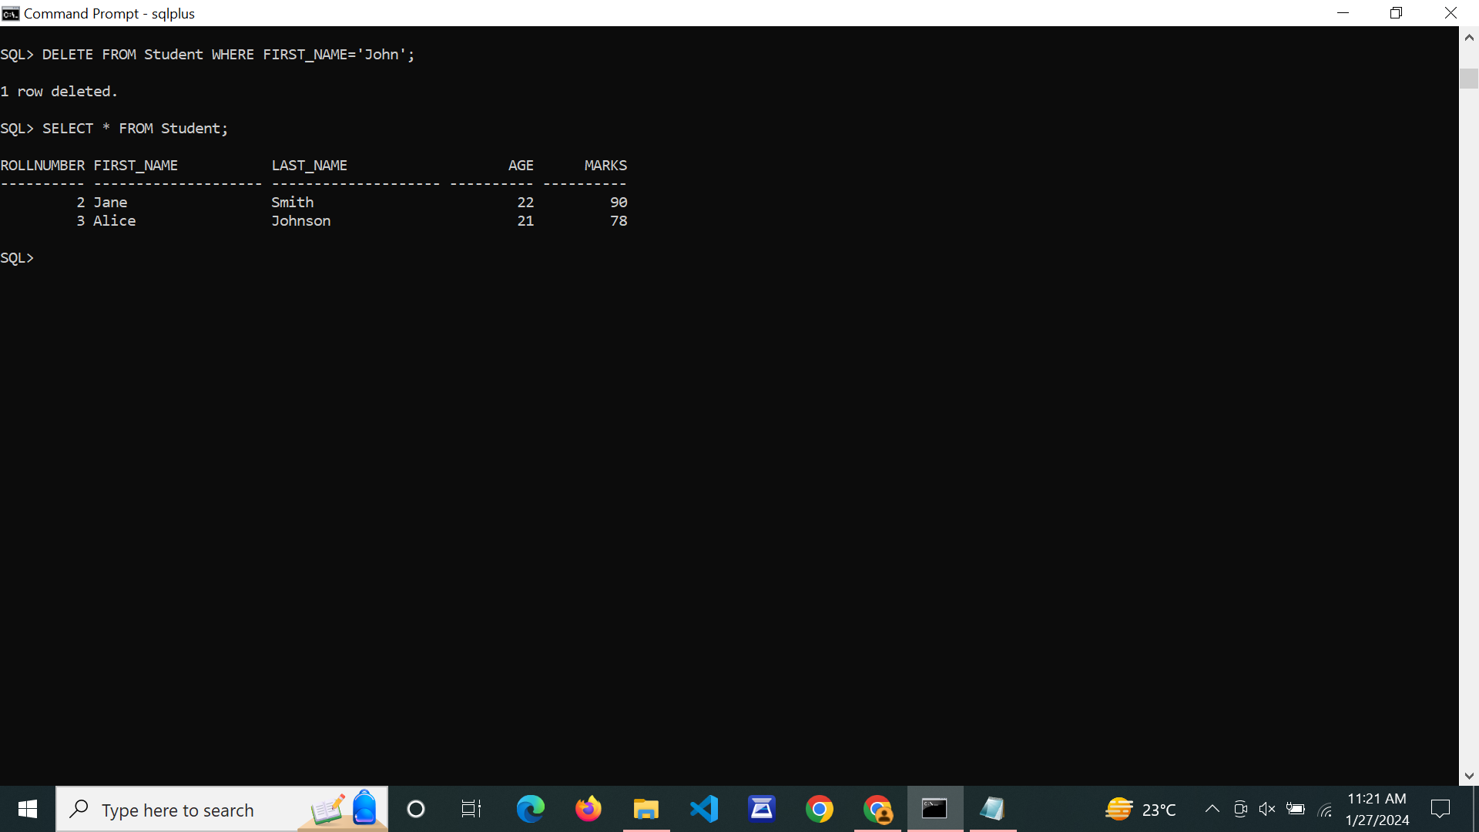

1. **Write SQL queries to create VIEWS for various databases (i.e. CREATE VIEW, UPDATE VIEW, ALTER VIEW, and DELETE VIEW).**

**CREATE VIEW:**

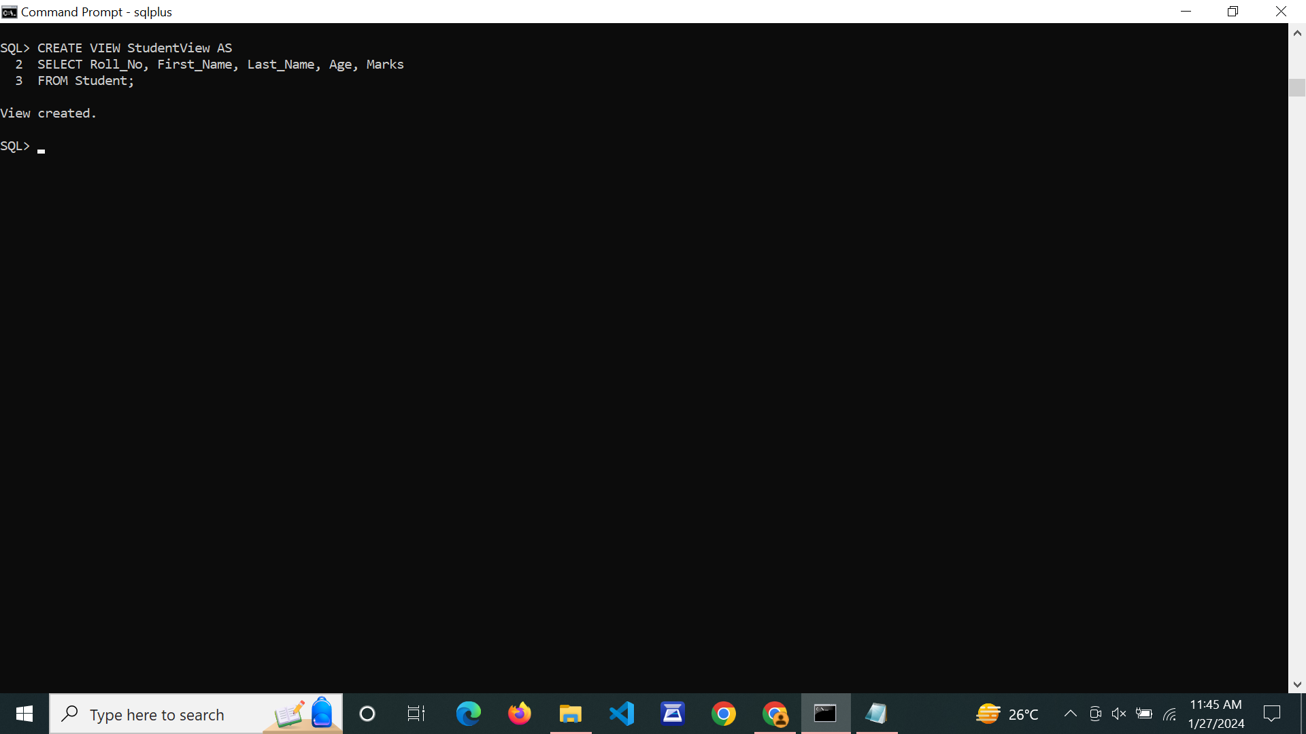

**UPDATE VIEW :**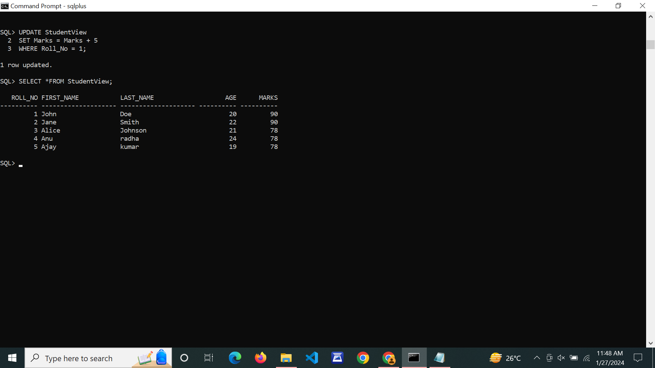

**DELETE VIEW:**

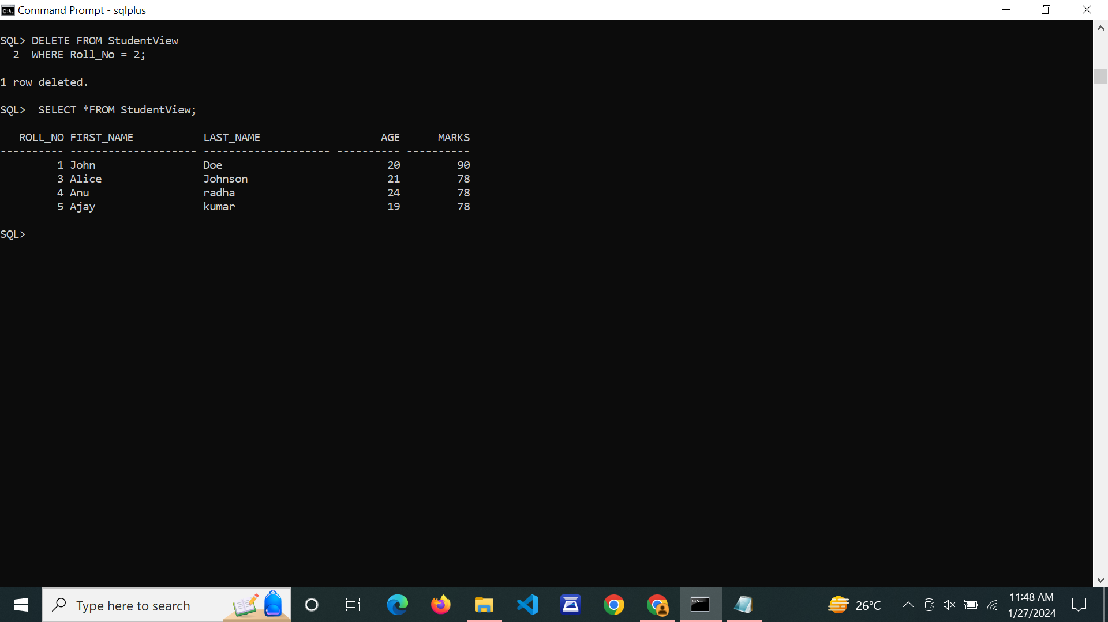

**ALTER VIEW** 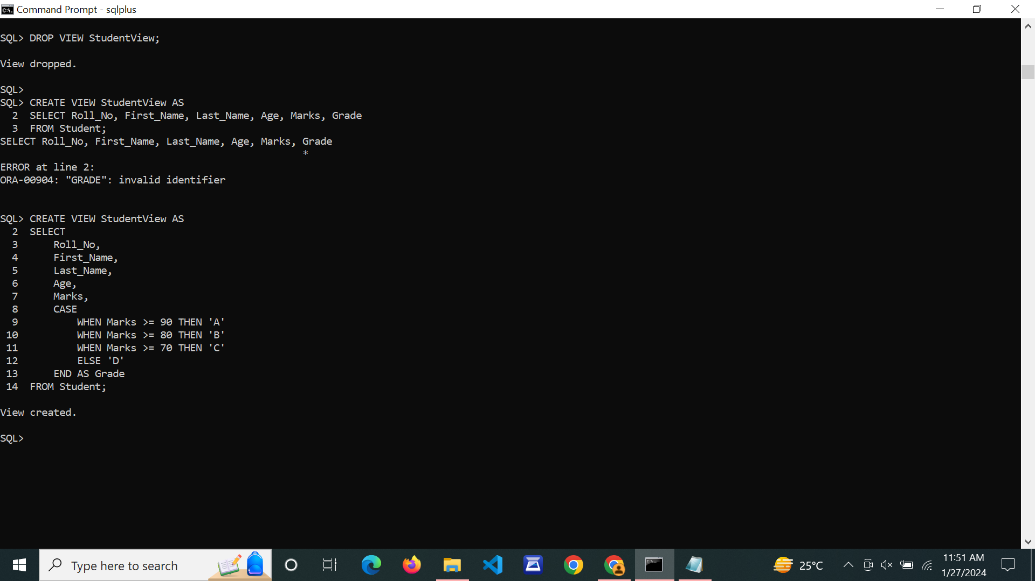

1. **Write SQL queries to perform RELATIONAL SET OPERATIONS (i.e. UNION, UNION ALL, INTERSECT, MINUS, CROSS JOIN, NATURAL JOIN).**

**CREATE TABLE & INSERT VALUES:**

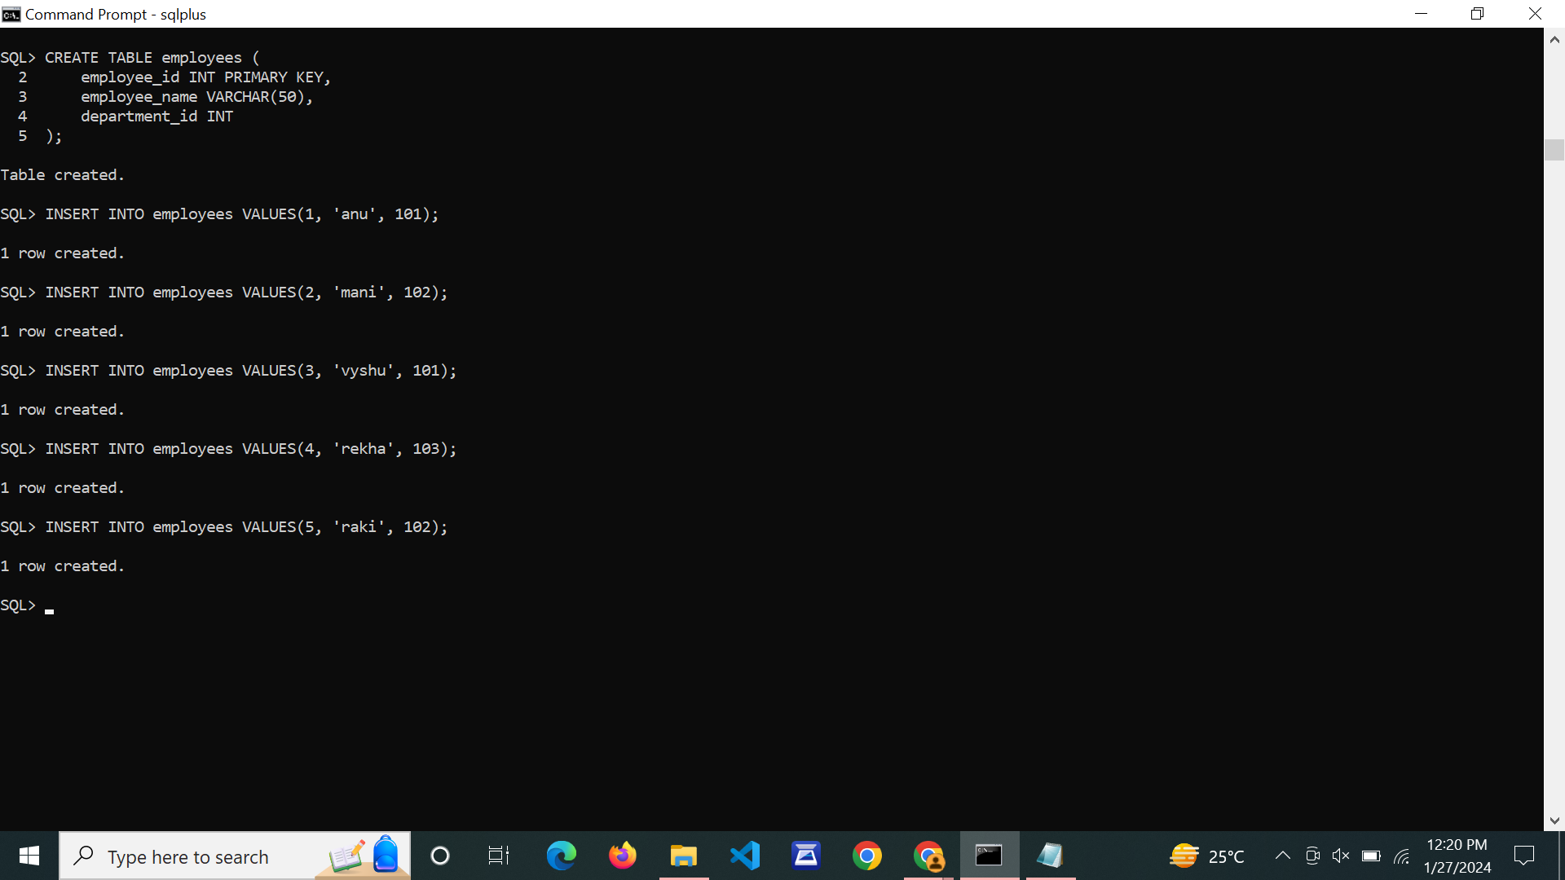

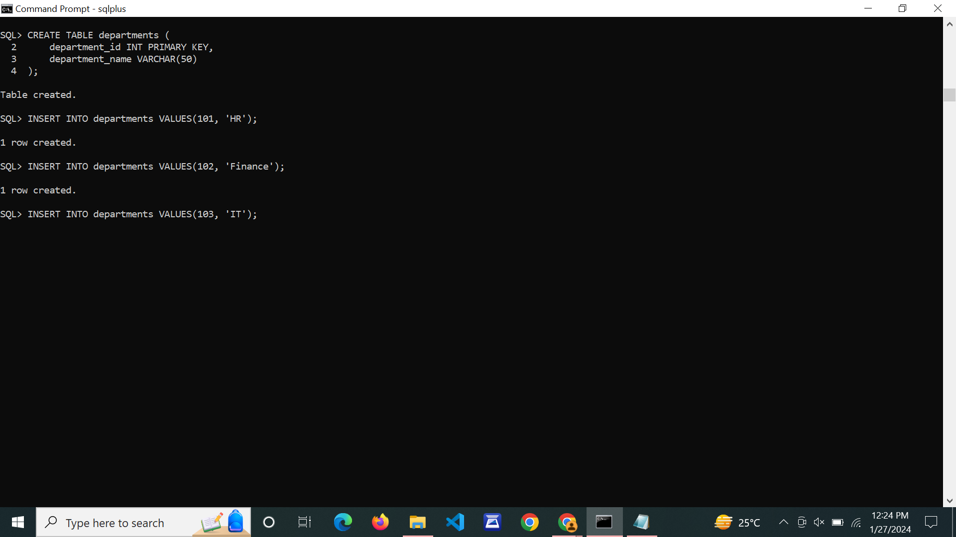

**UNION:**

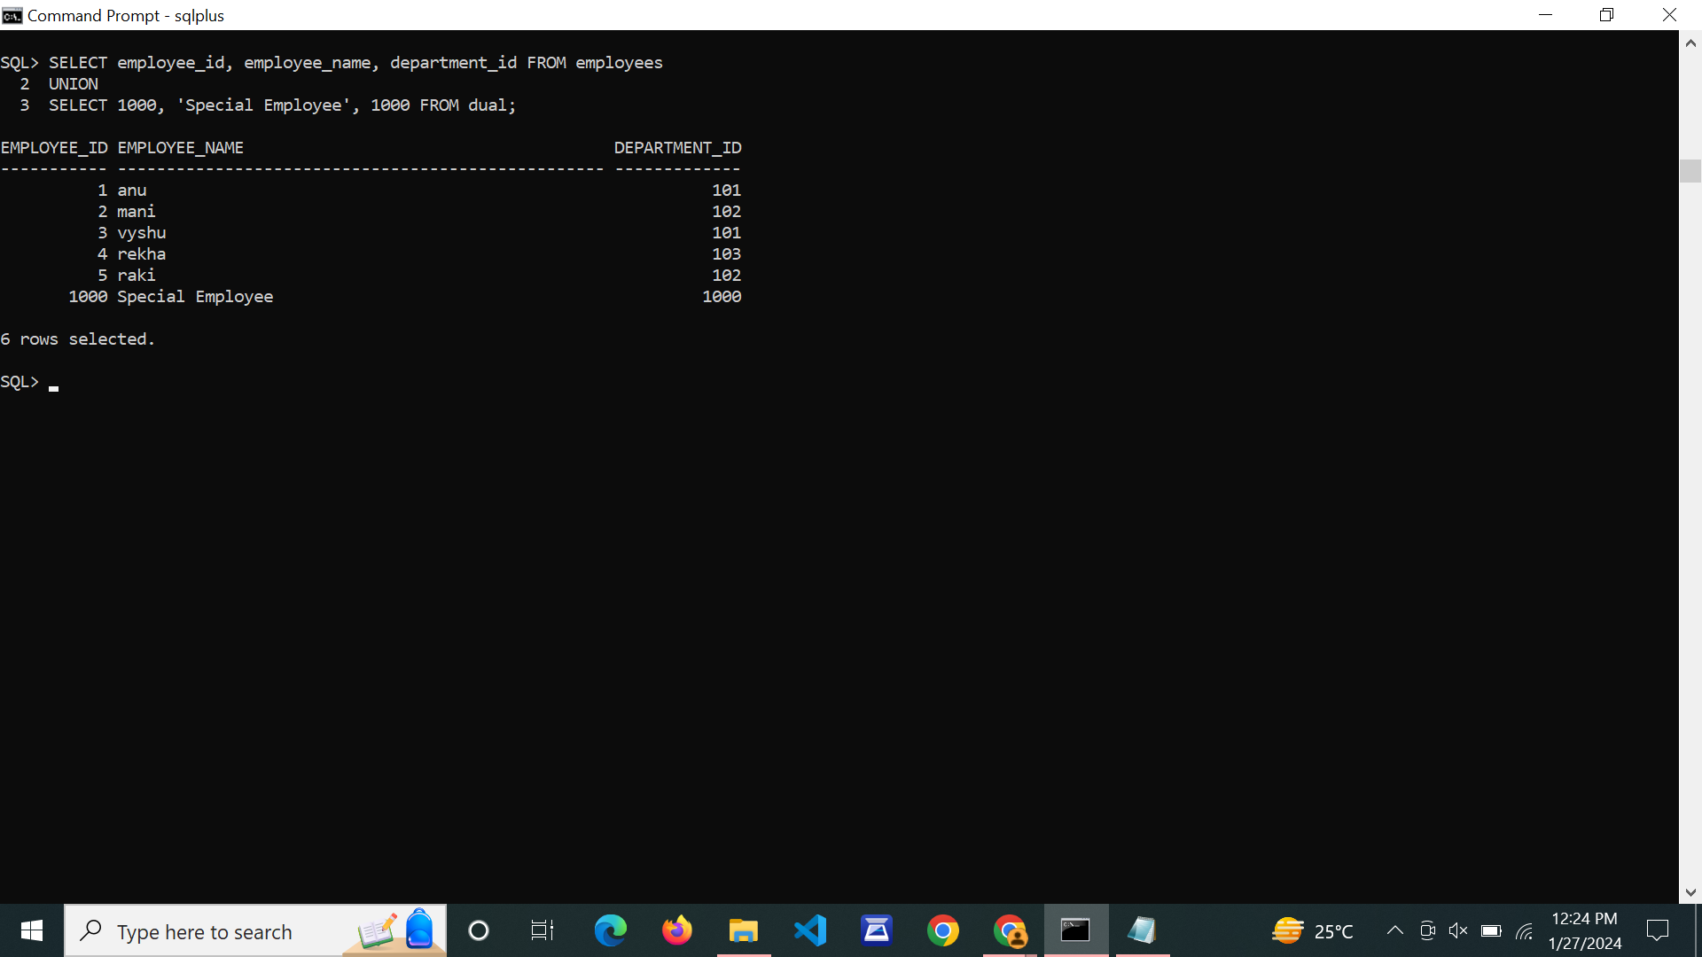

**UNION ALL:**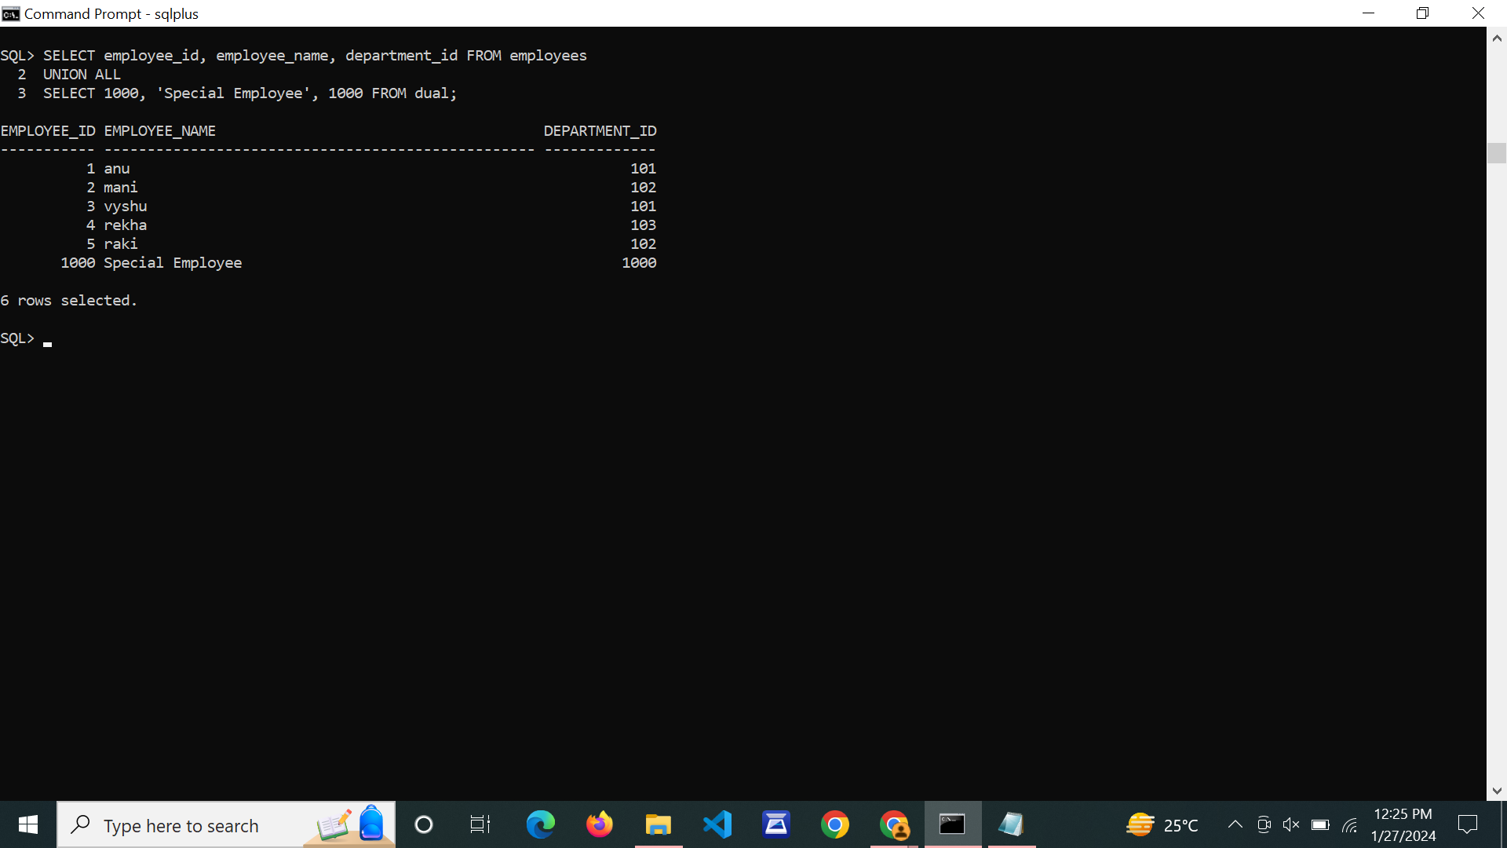

**INTERSECT:**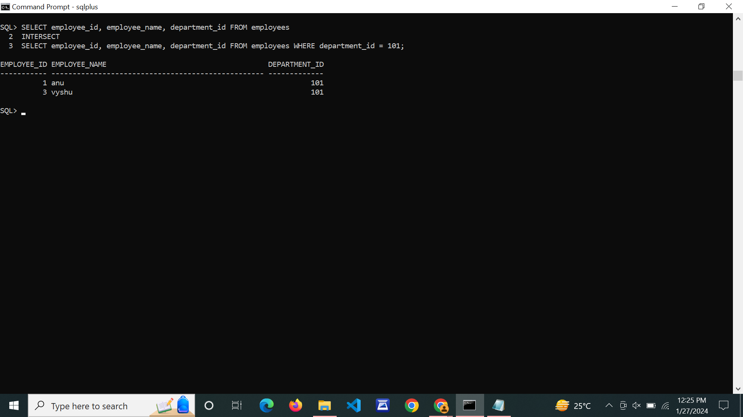

**MINUS:**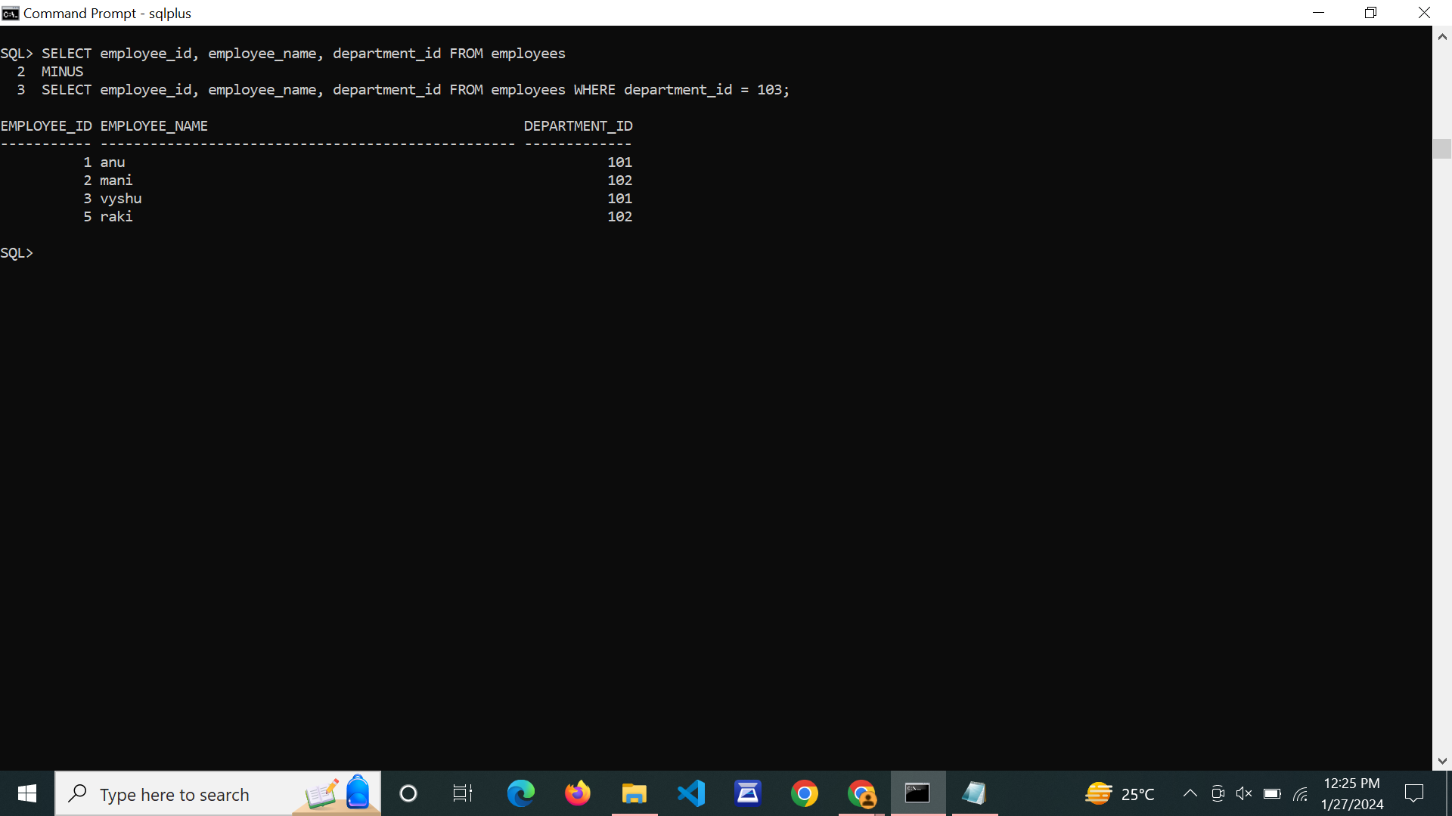

**CROSS JOIN:**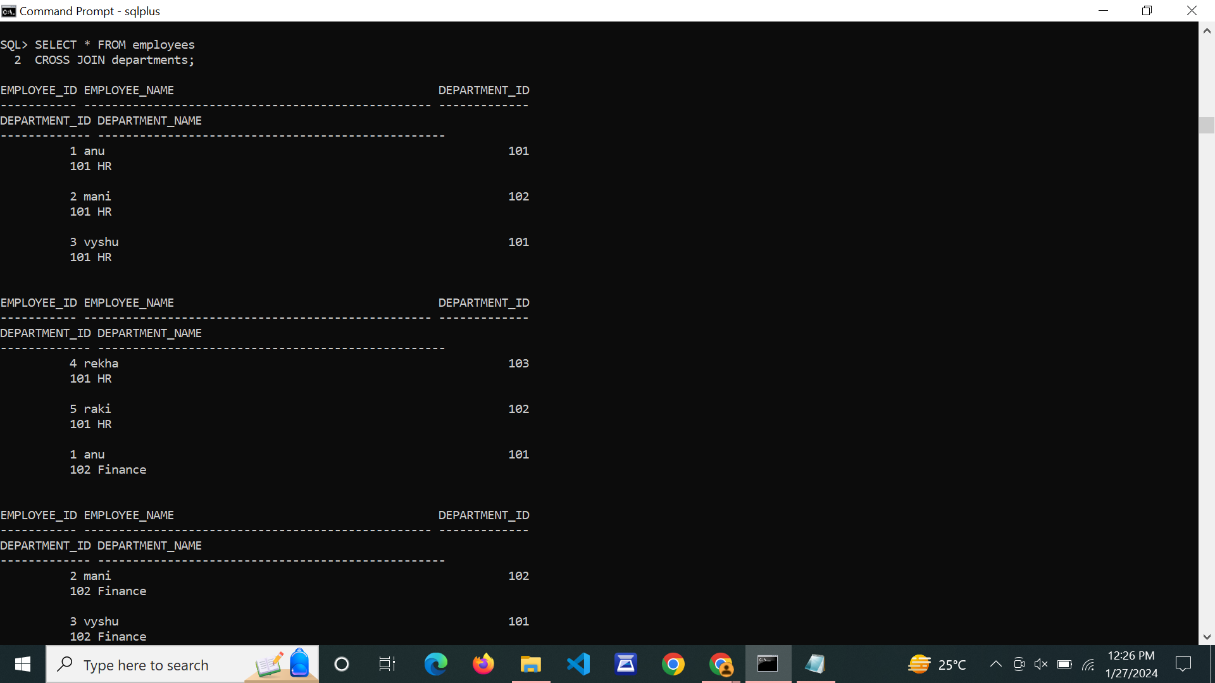

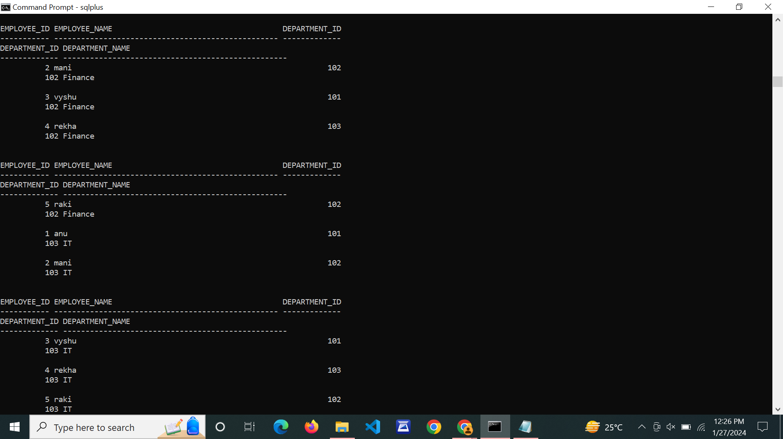

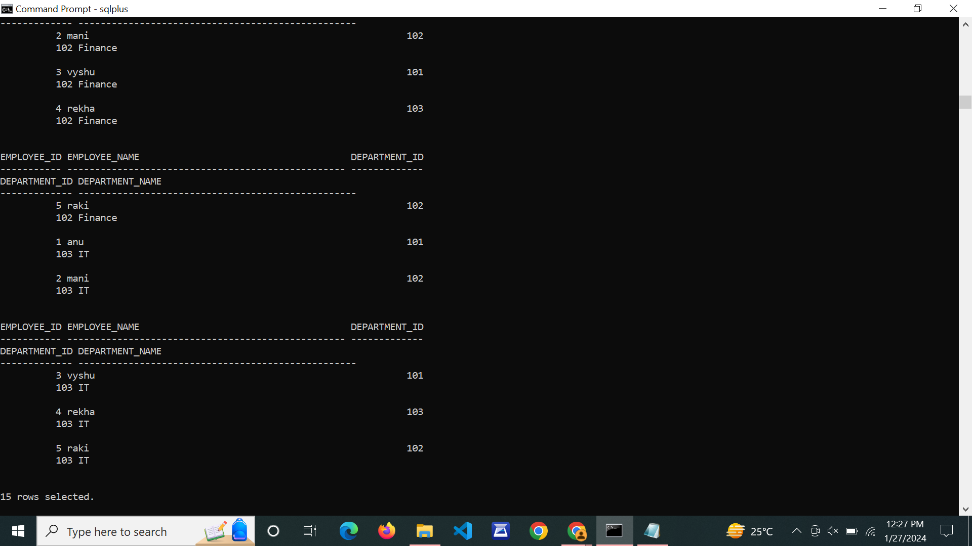

**NATURAL JOIN:**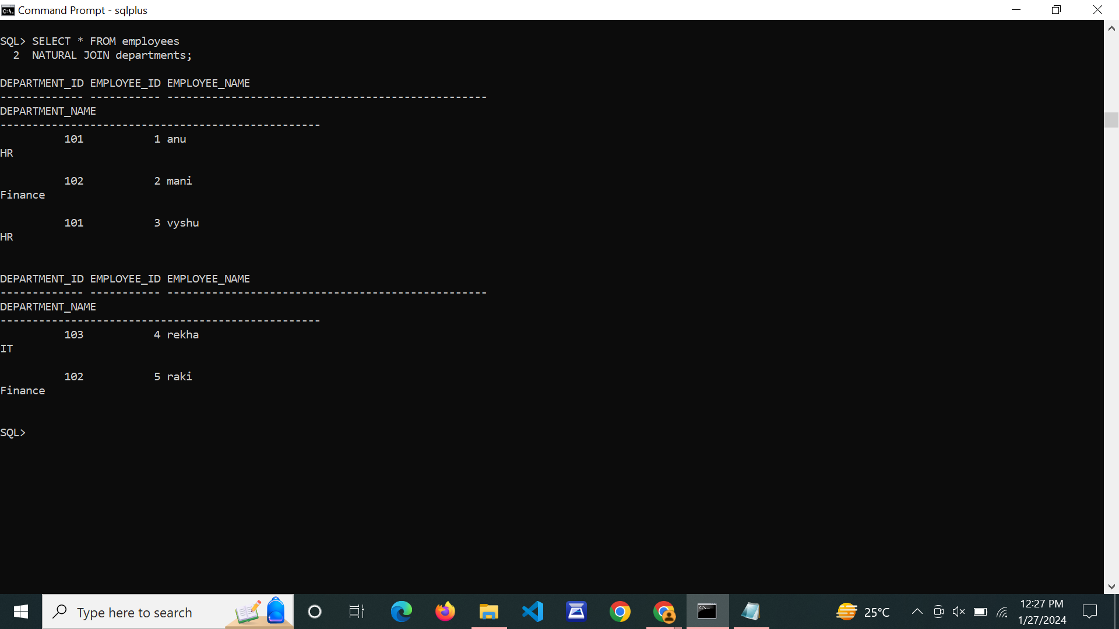

1. **Write SQL queries to perform SPECIAL OPERATIONS (i.e. ISNULL, BETWEEN, LIKE, IN, EXISTS).**

**CREATE TABLE & INSERT VALUES:**

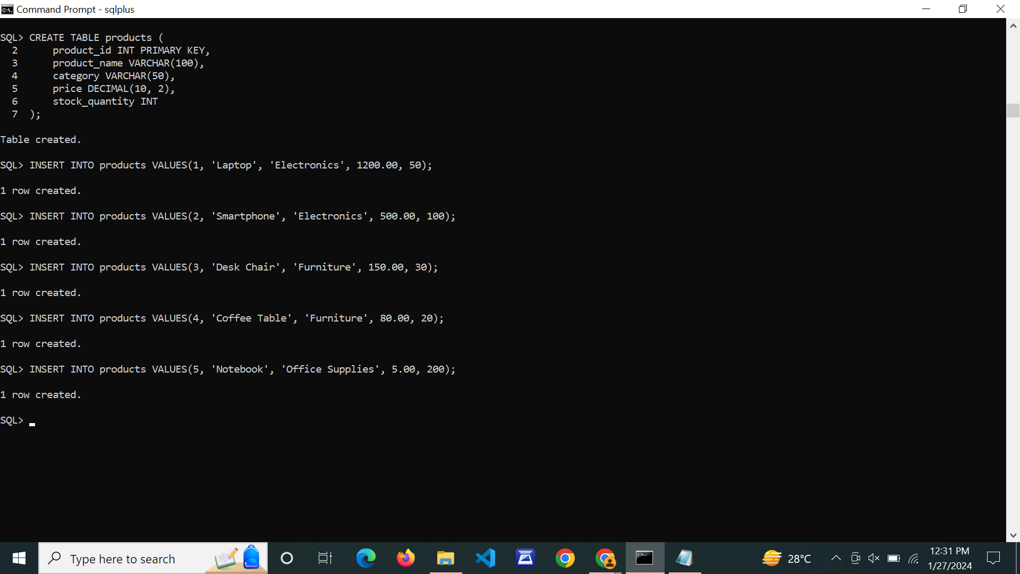

**IS NULL:**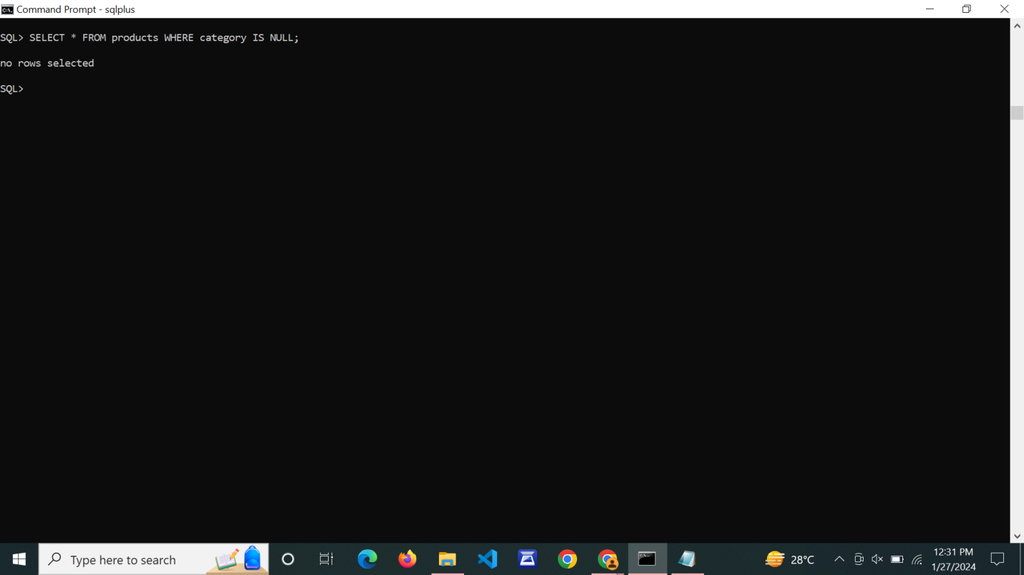

**BETWEEN:**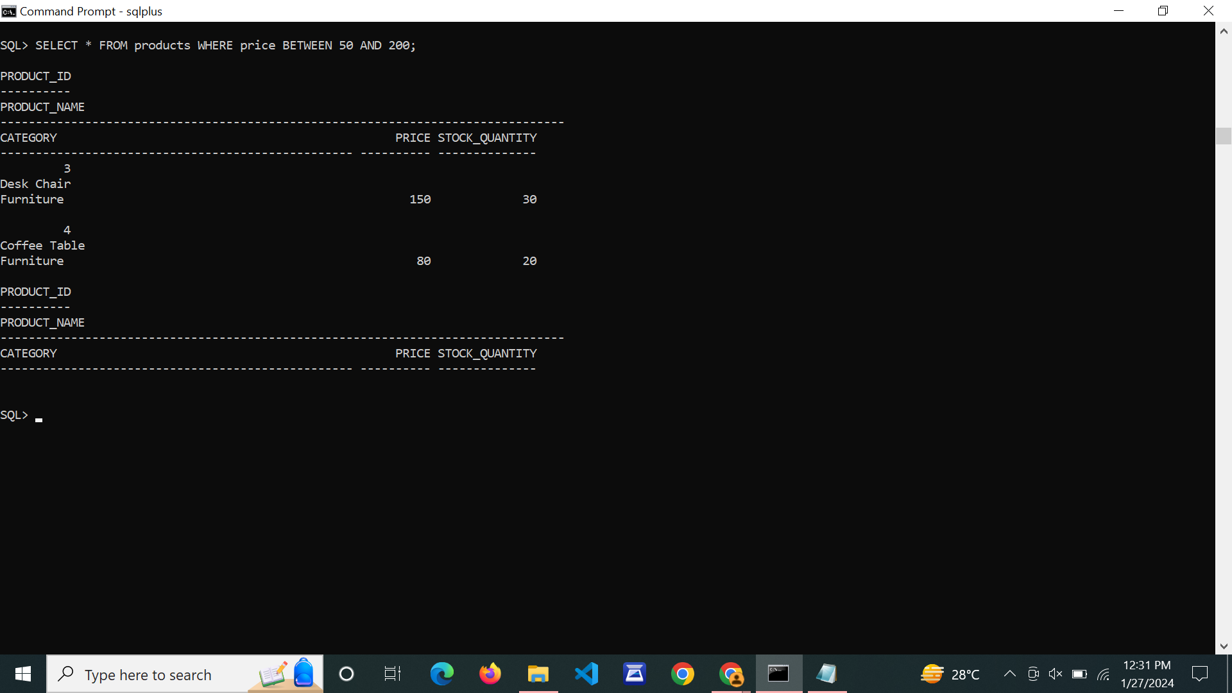

**LIKE:**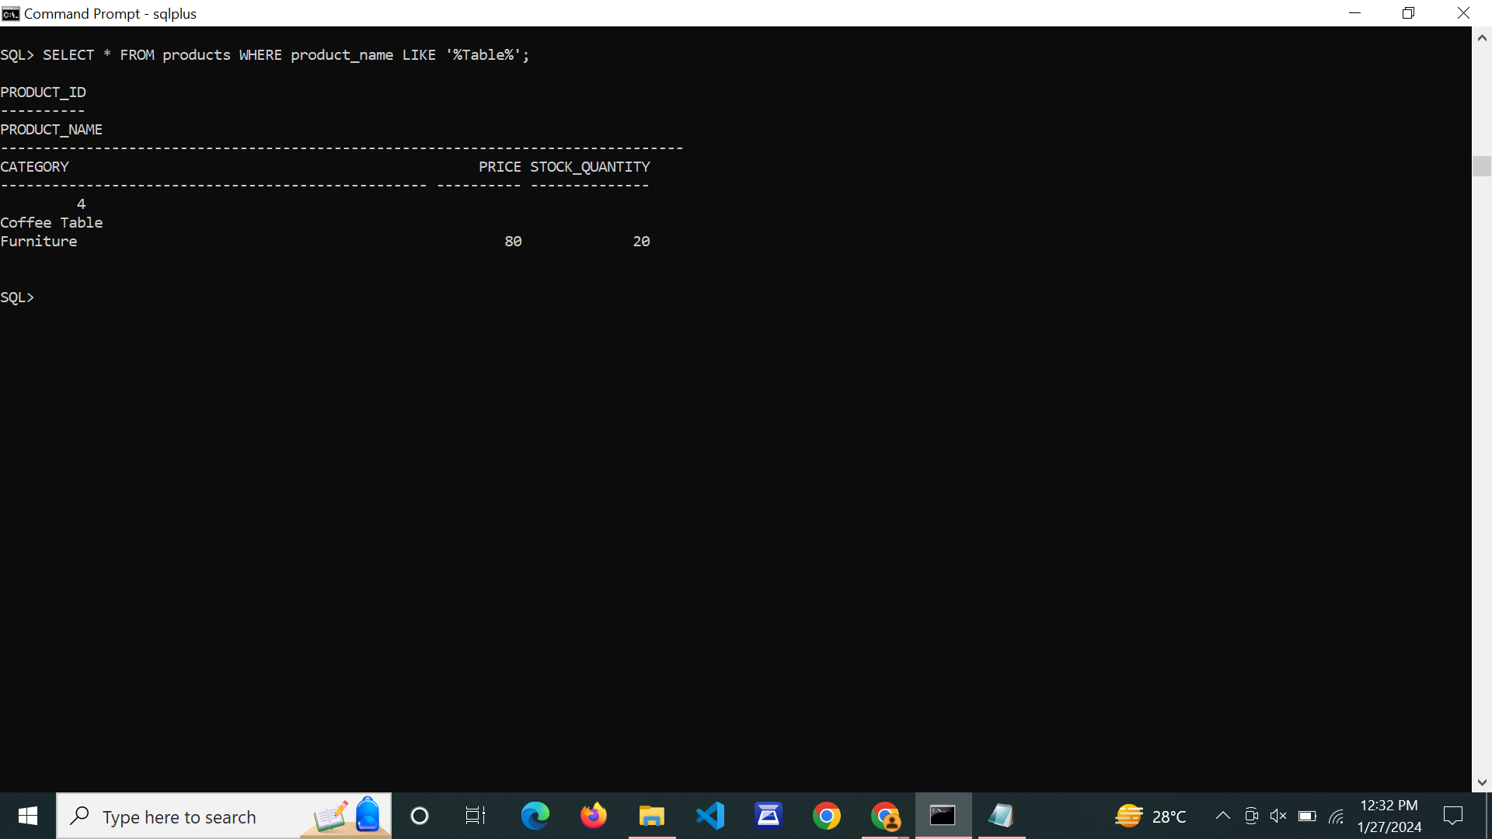

**IN:**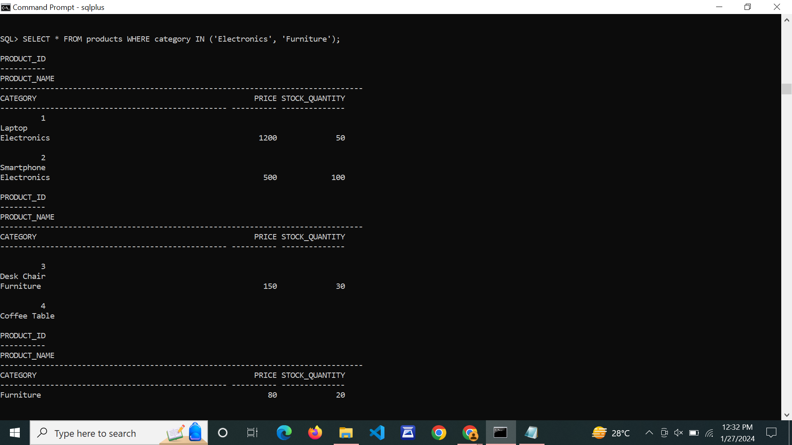

**EXISTS:**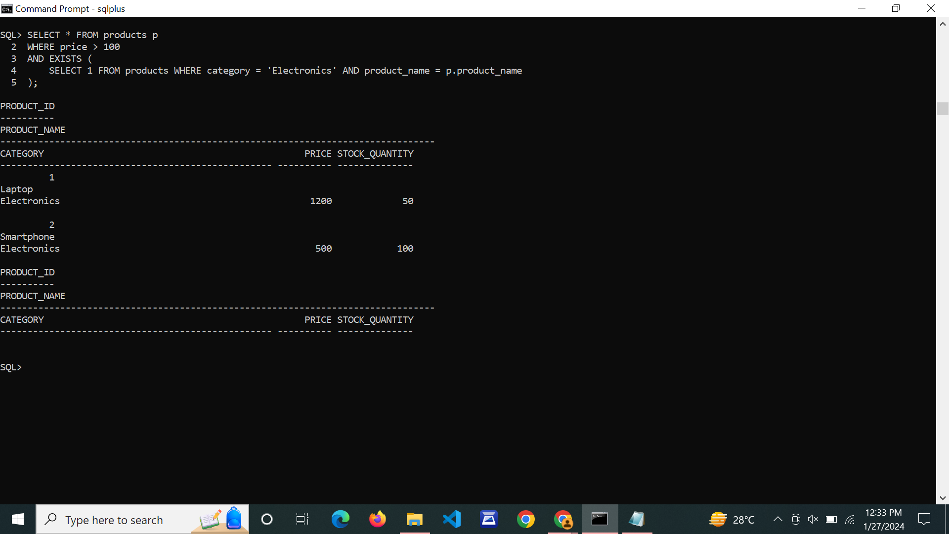

1. **Write SQL queries to perform JOIN OPERATIONS (i.e. CONDITIONAL JOIN, EQUI JOIN, LEFT OUTER JOIN, RIGHT OUTER JOIN, FULL OUTER JOIN)**

**CREATE TABLE & INSERT VALUES:**

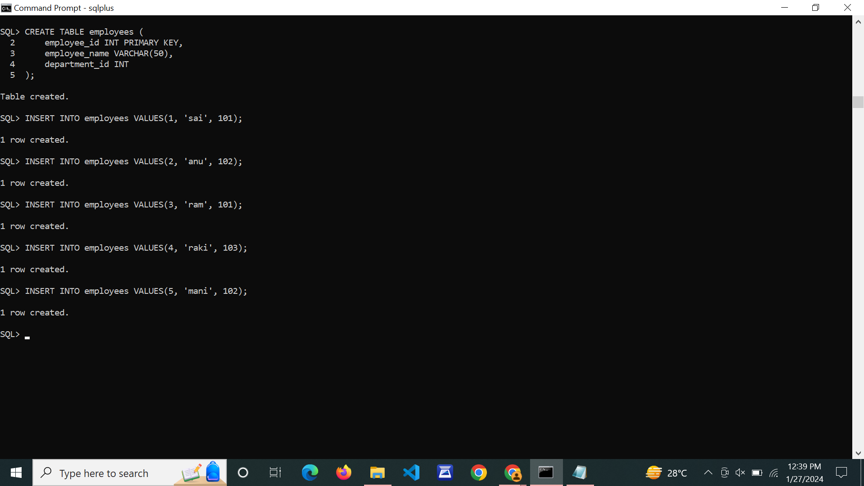

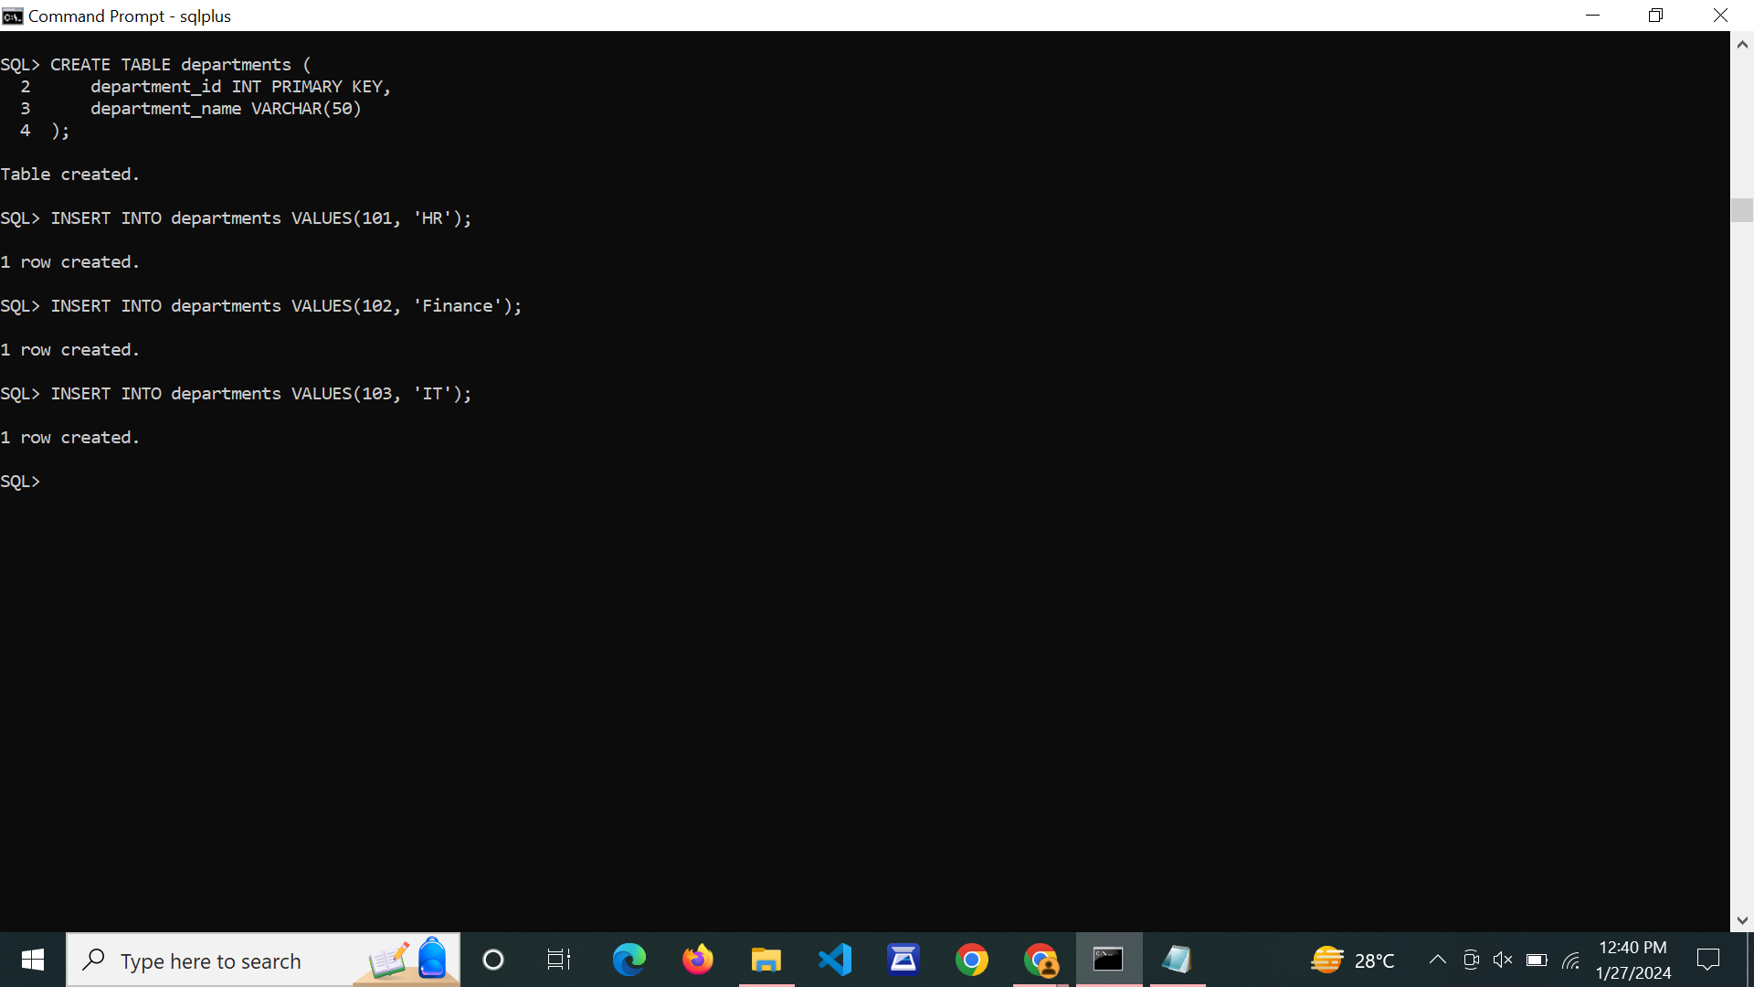

**INNER JOIN:**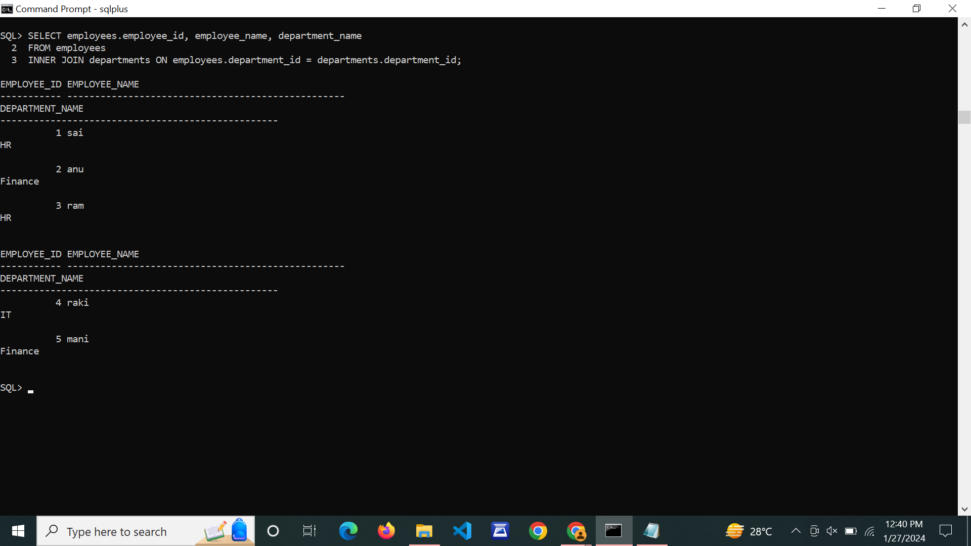

**LEFT OUTER JOIN:**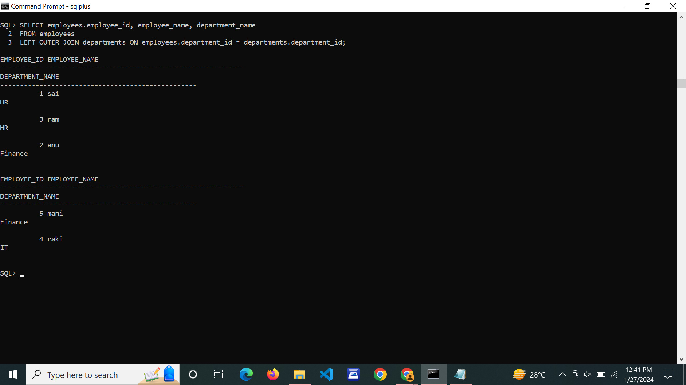

**RIGHT OUTER JOIN:**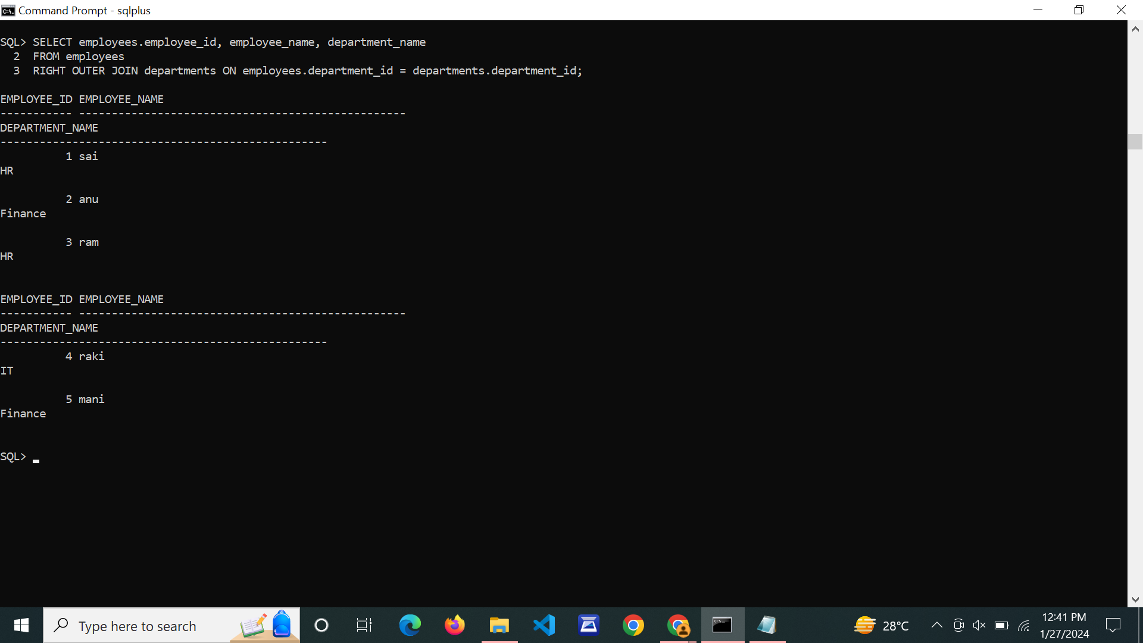

**FULL OUTER JOIN:**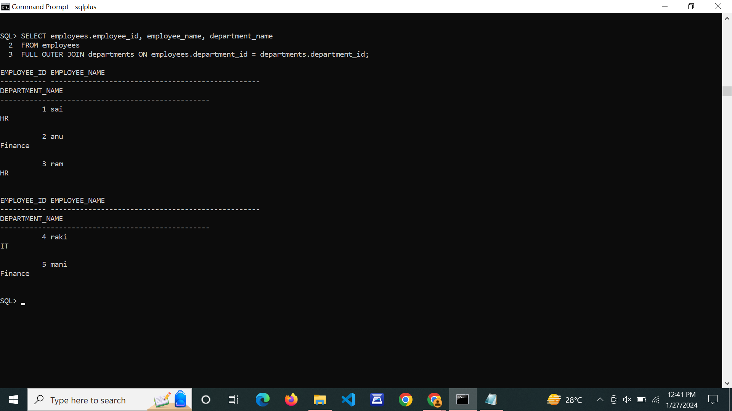

1. **Write SQL queries to perform AGGREGATE OPERATIONS (i.e. SUM, COUNT, AVG, MIN, MAX).**

**CREATE TABLE & INSERT VALUES:**



**SUM:**

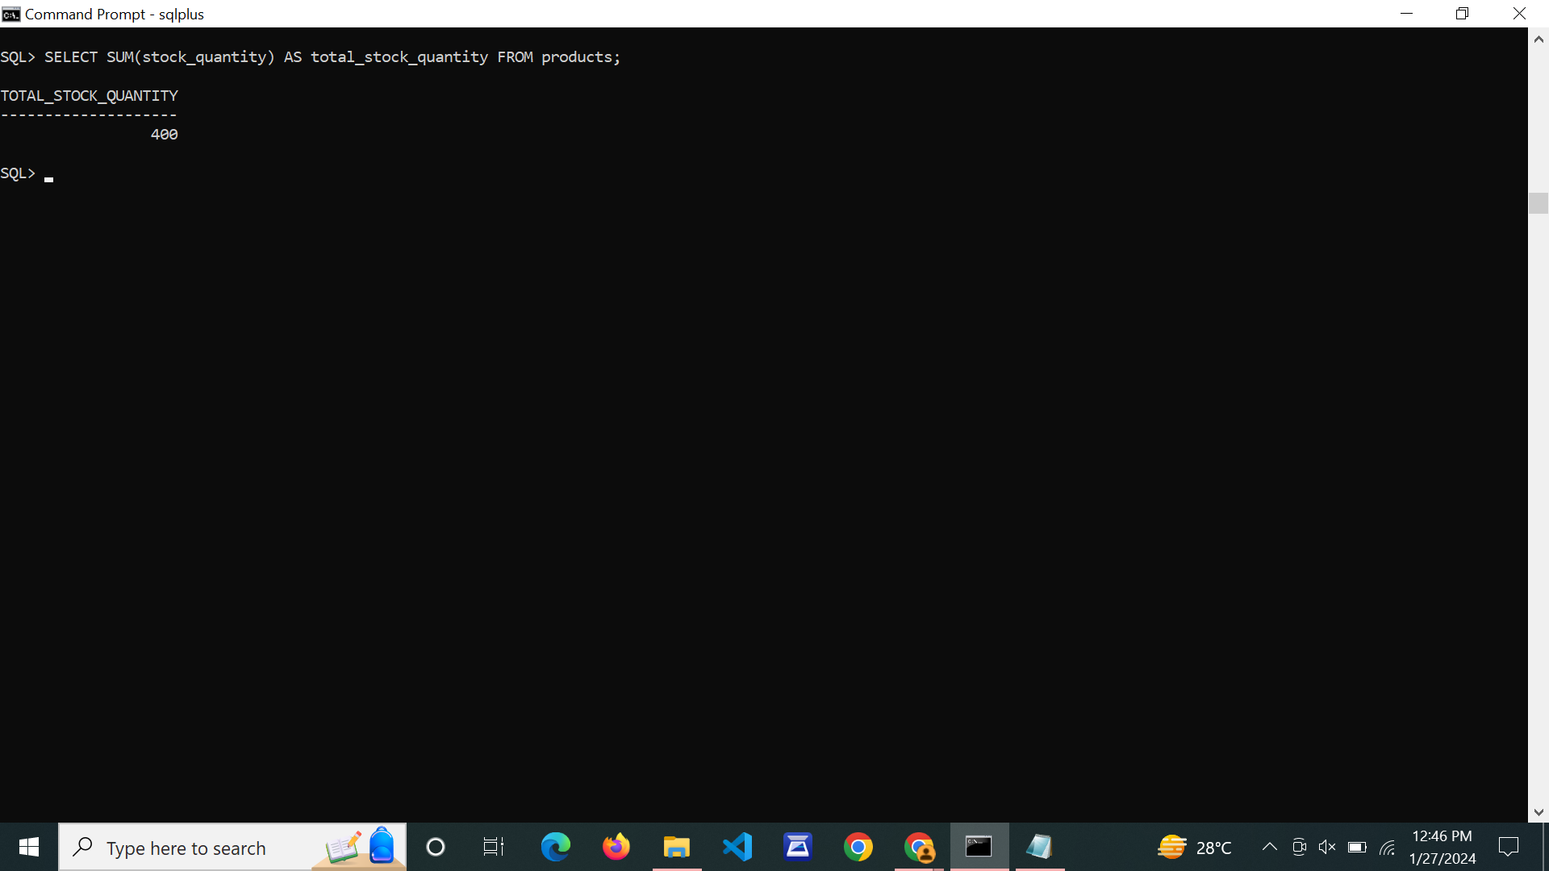

**COUNT:**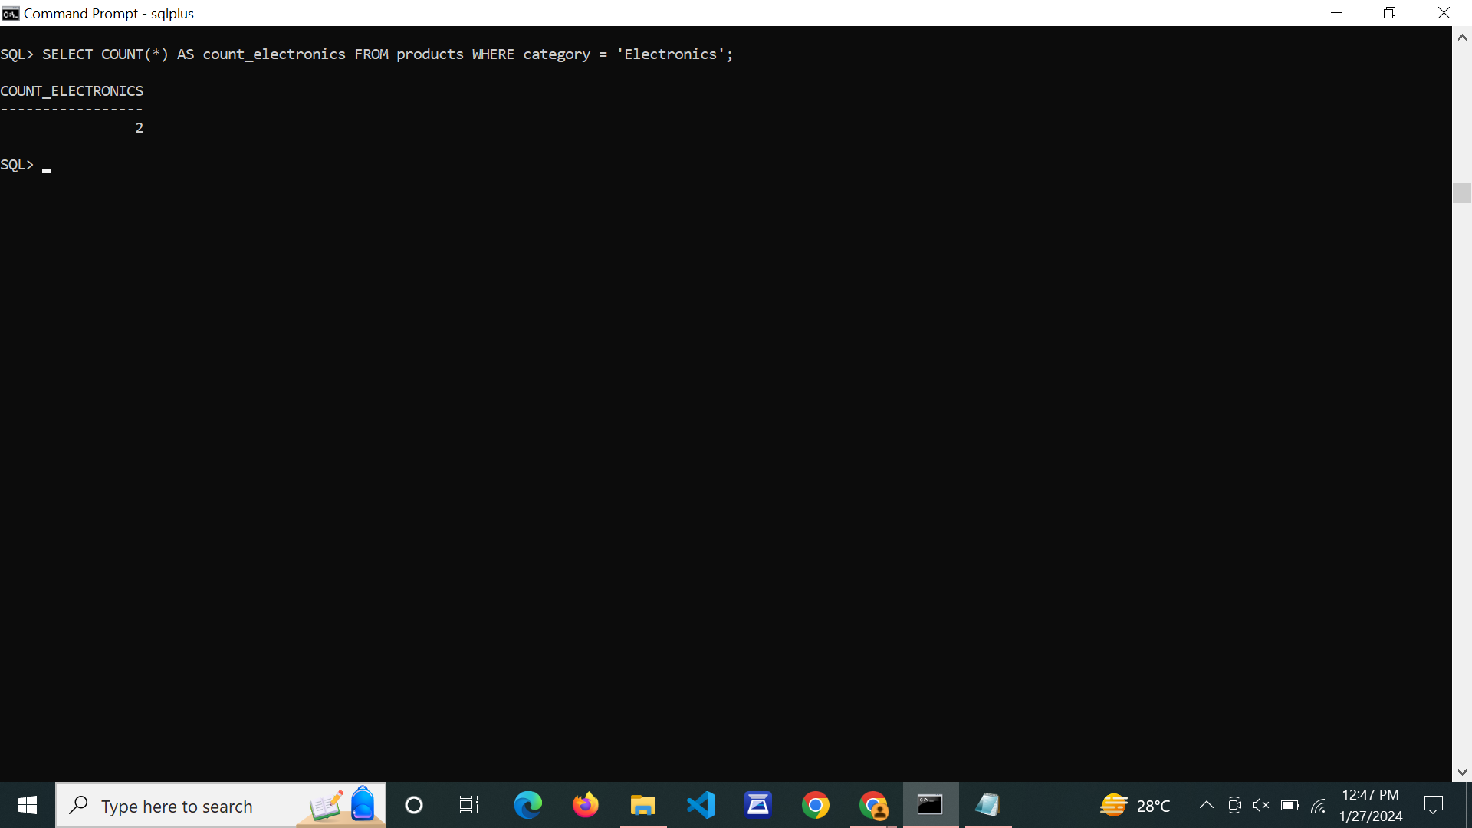

**AVG:**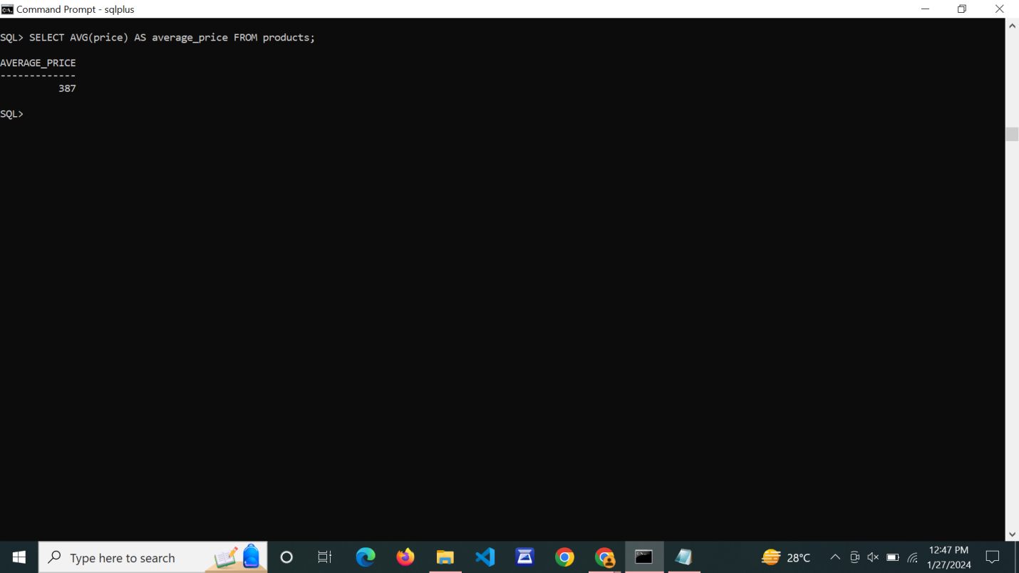

**MIN:**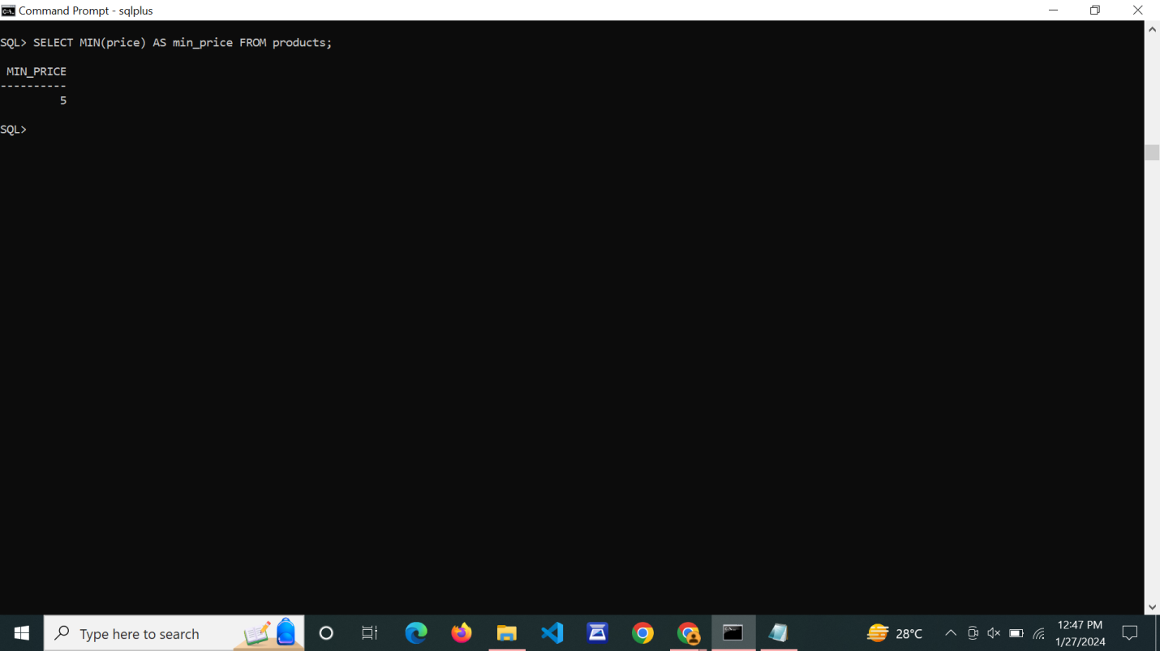

**MAX:**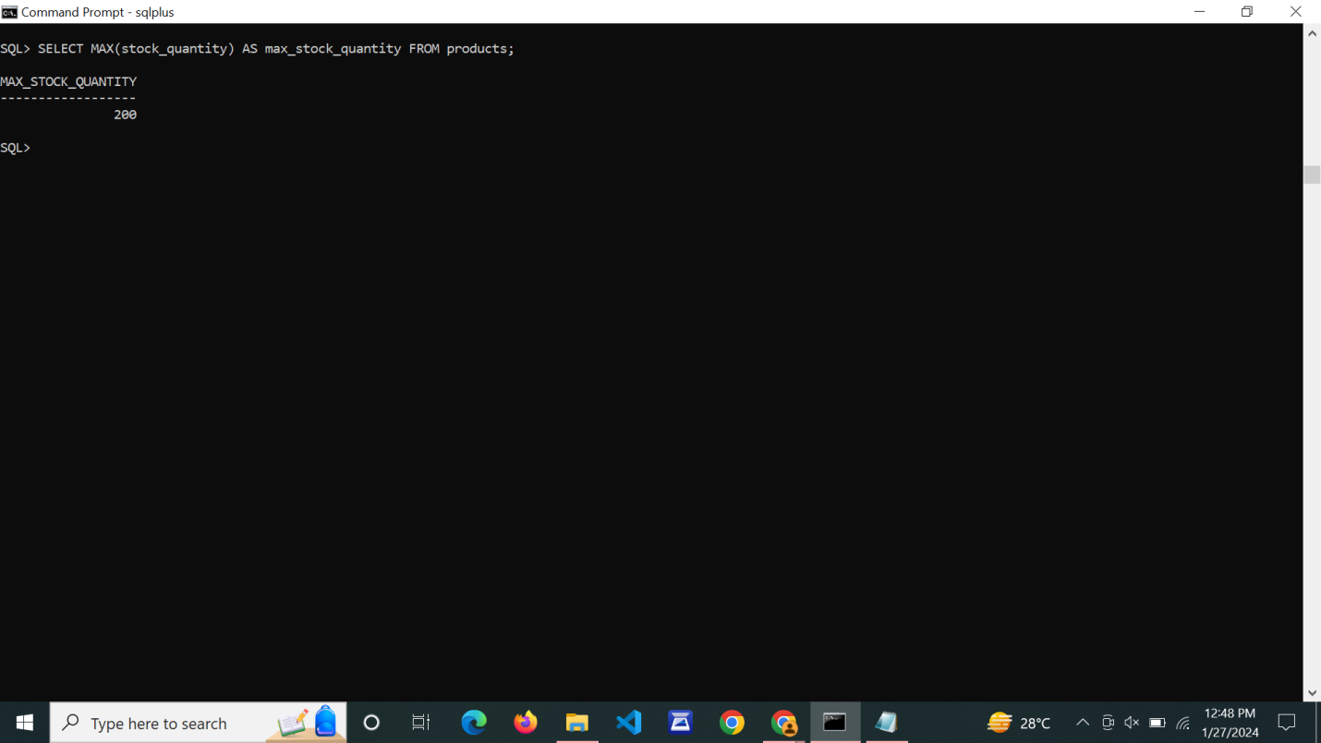

1. **Write SQL queries to perform ORACLE BUILT-IN FUNCTIONS (i.e. DATE, TIME).**

**Character Functions:**

**case-conversion functions**

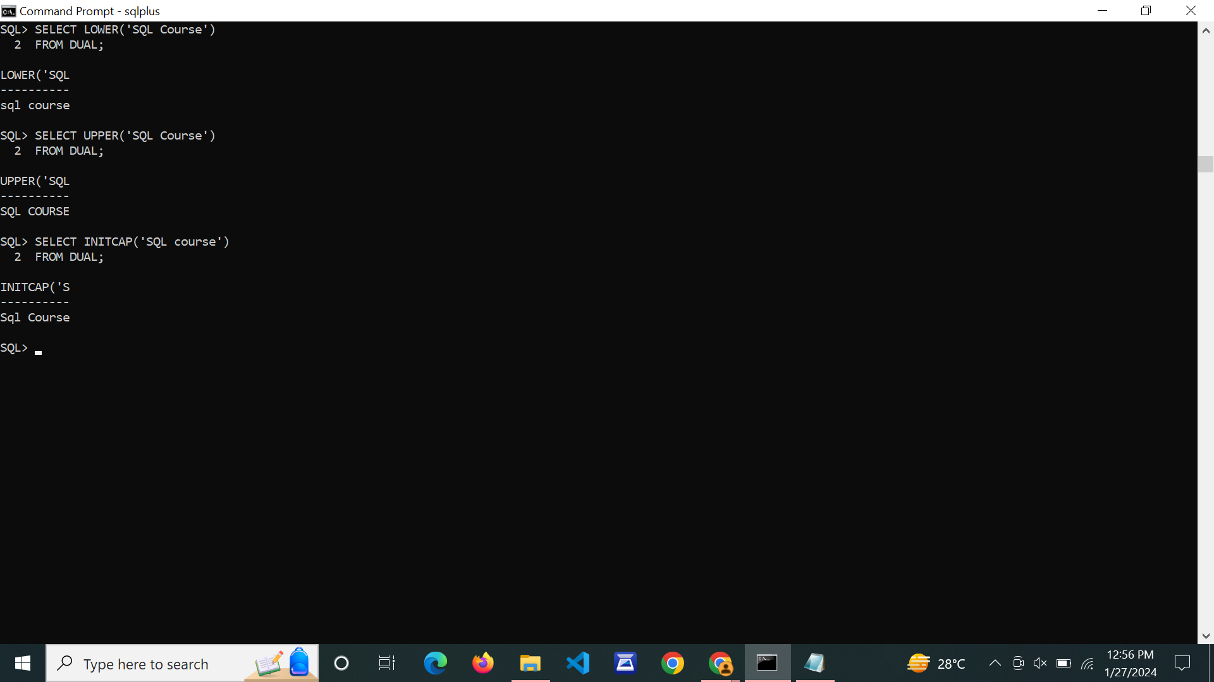

**character manipulation functions**

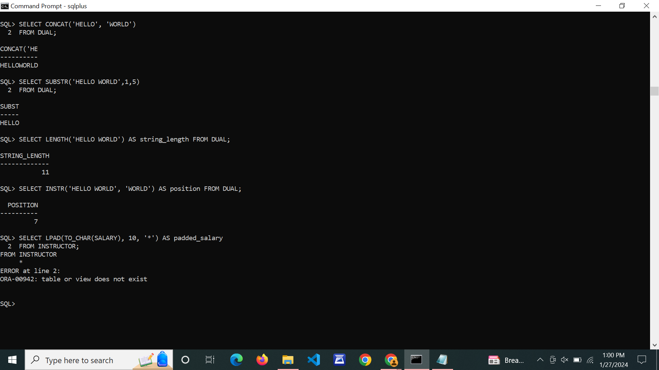

**DATE Functions:**

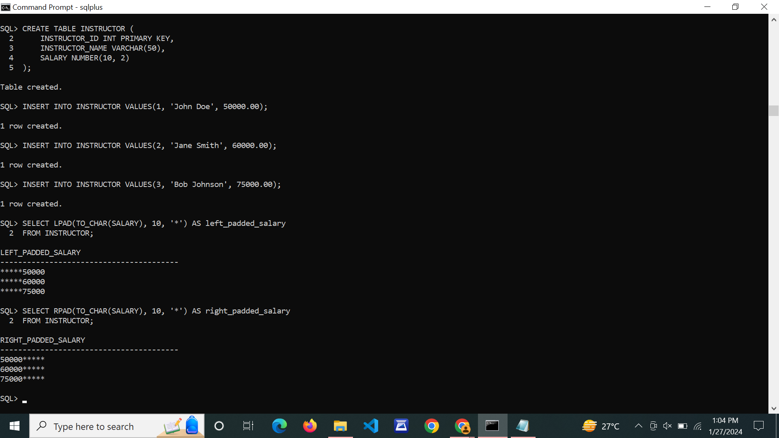

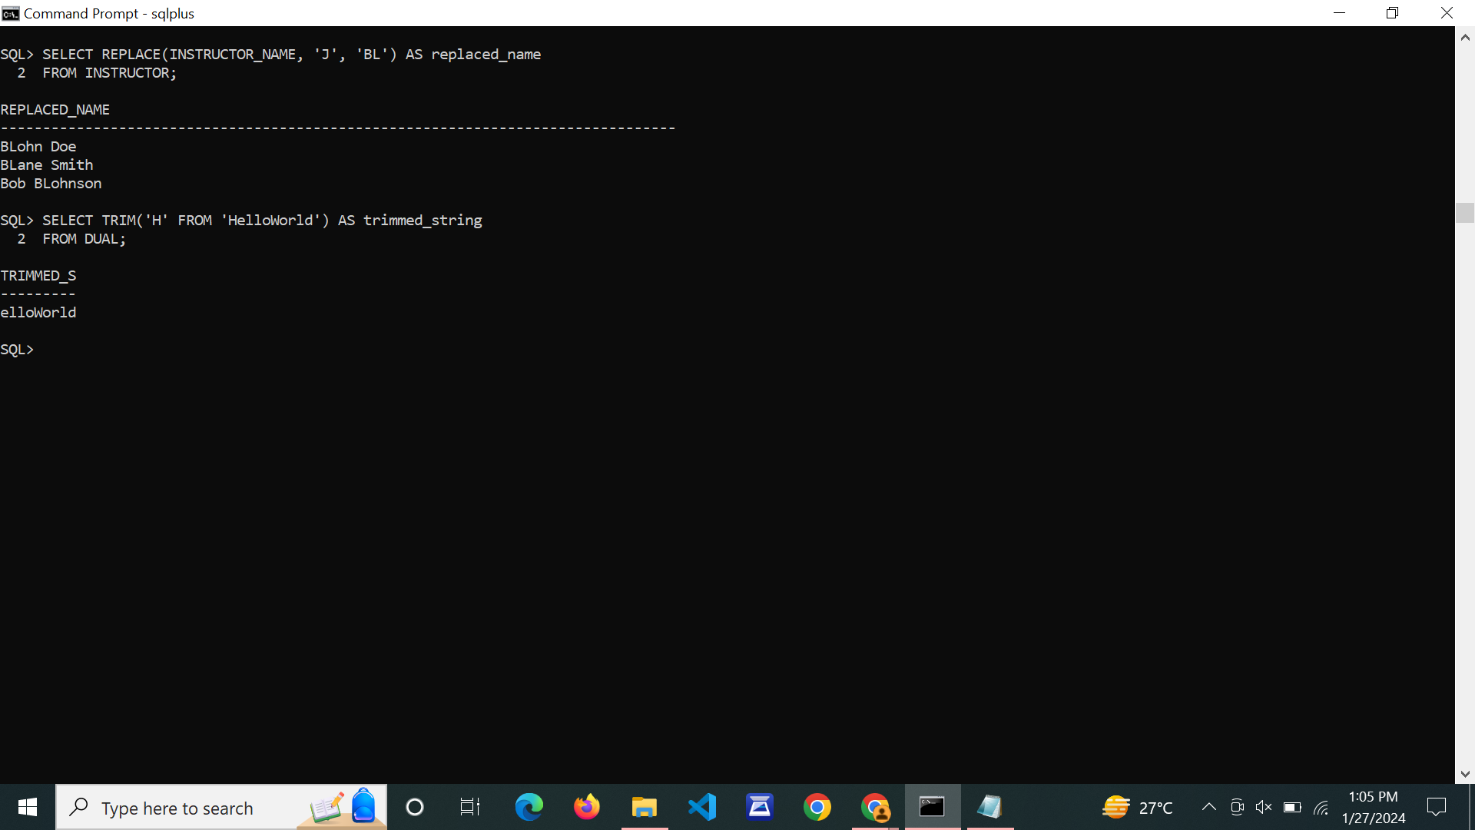

**NUMBER FUNCTIONS:**

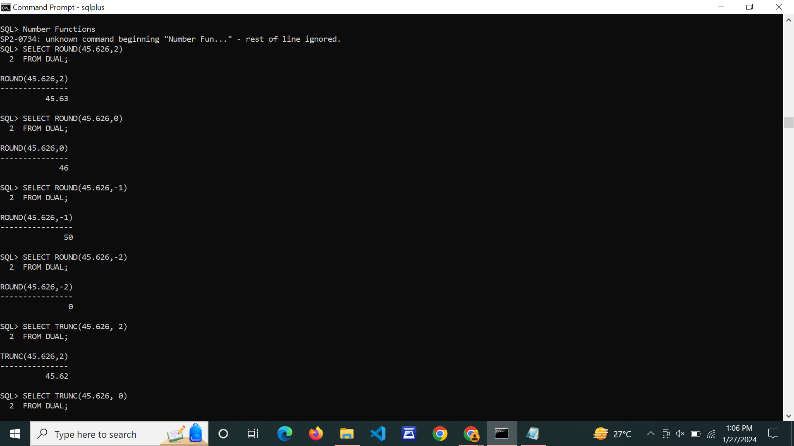

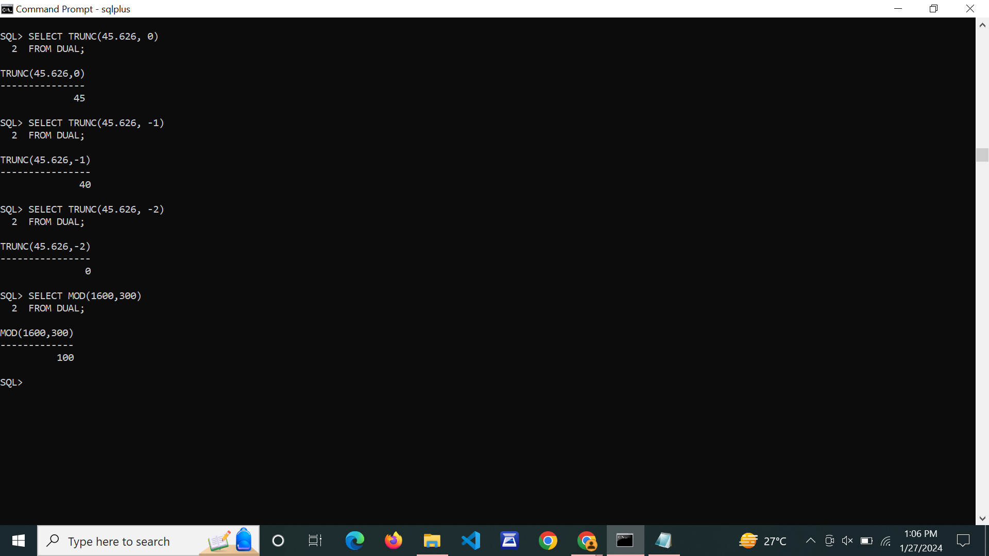

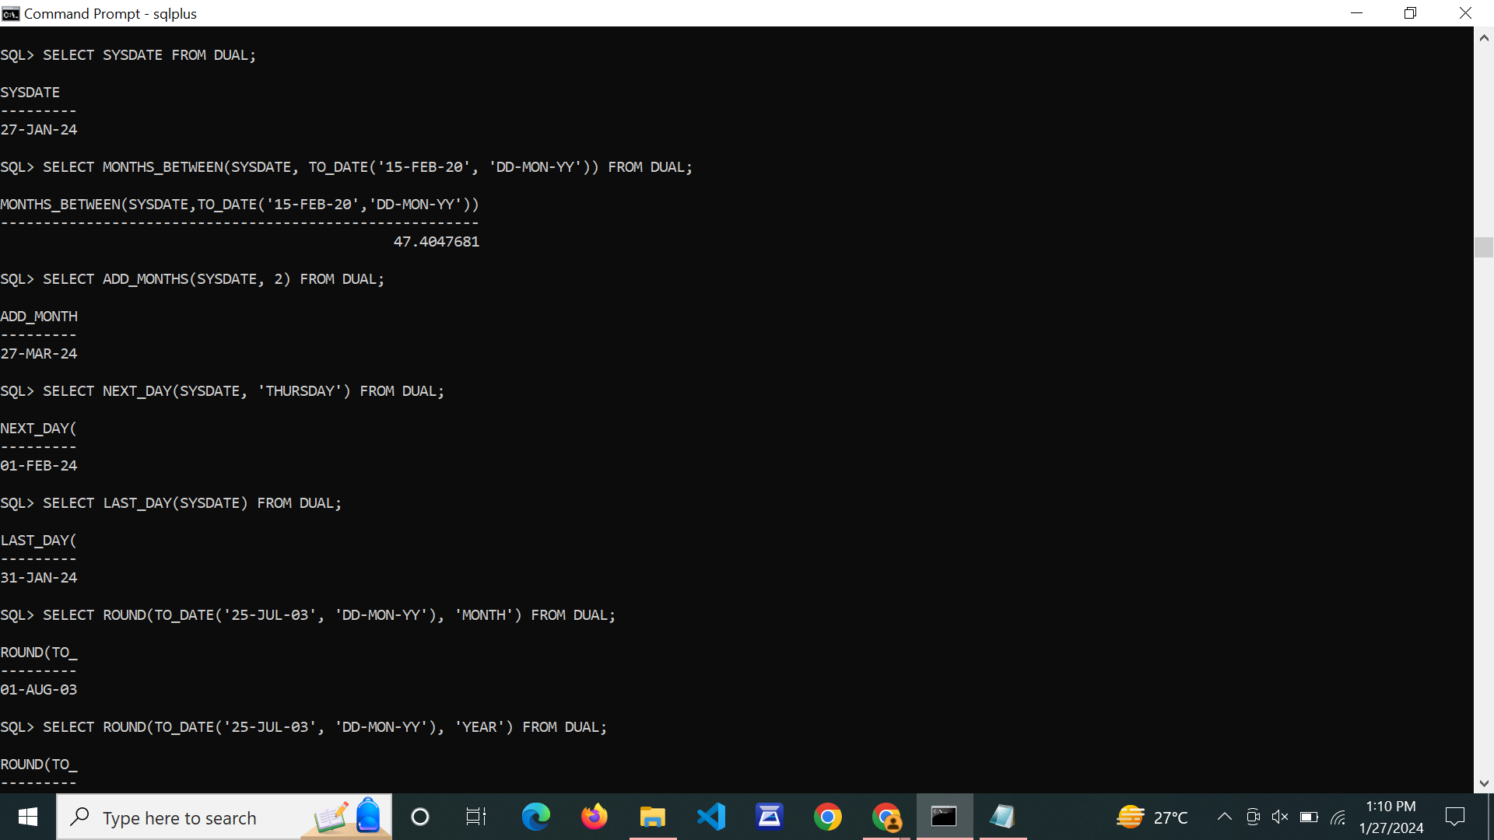

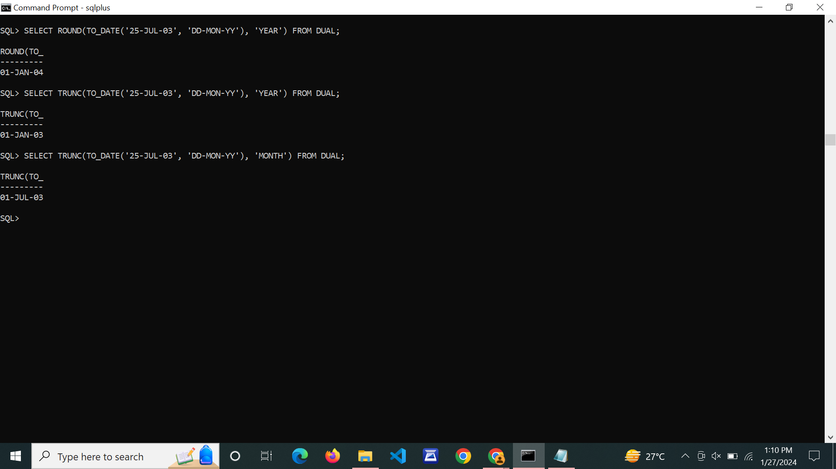

1. **Write SQL queries to perform KEY CONSTRAINTS (i.e. PRIMARY KEY, FOREIGN KEY, UNIQUE NOT NULL, CHECK, DEFAULT).**

**PRIMARY KEY:**

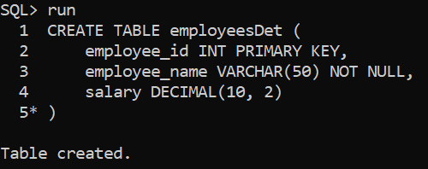

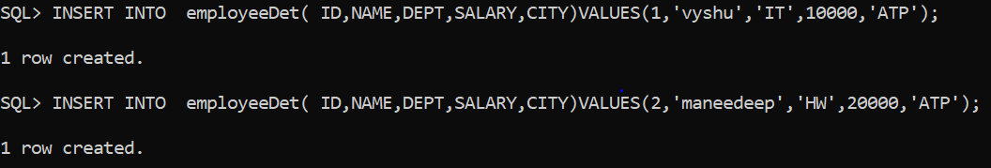

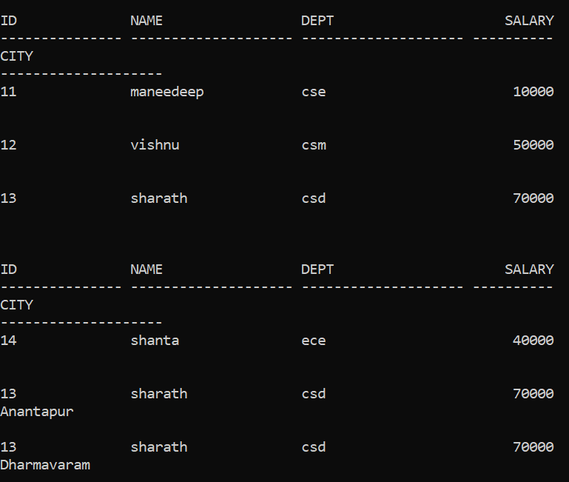

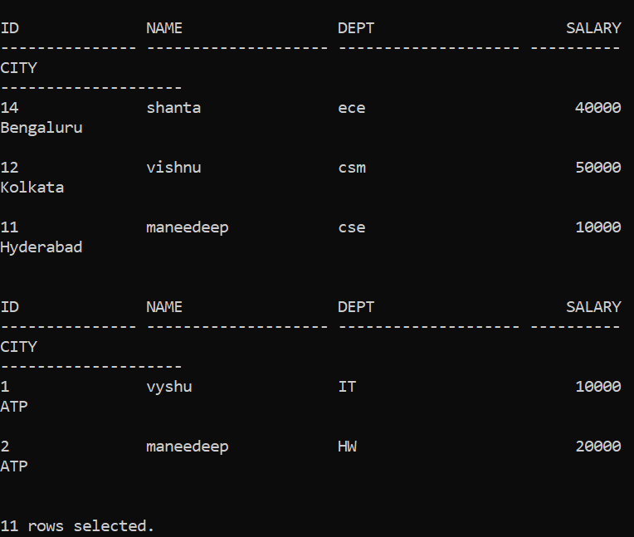

**Foreign Key:**

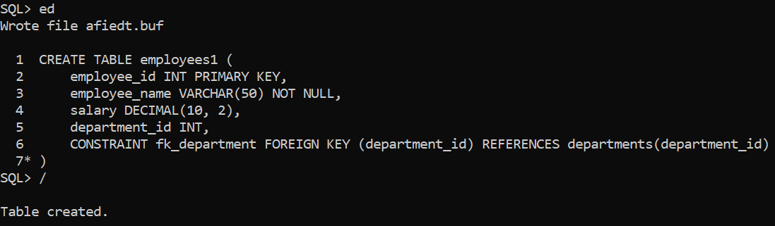

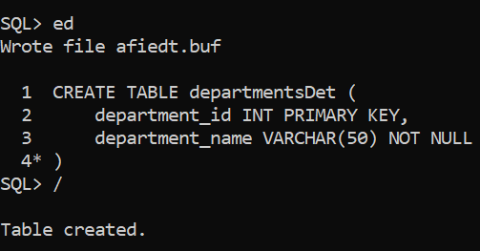

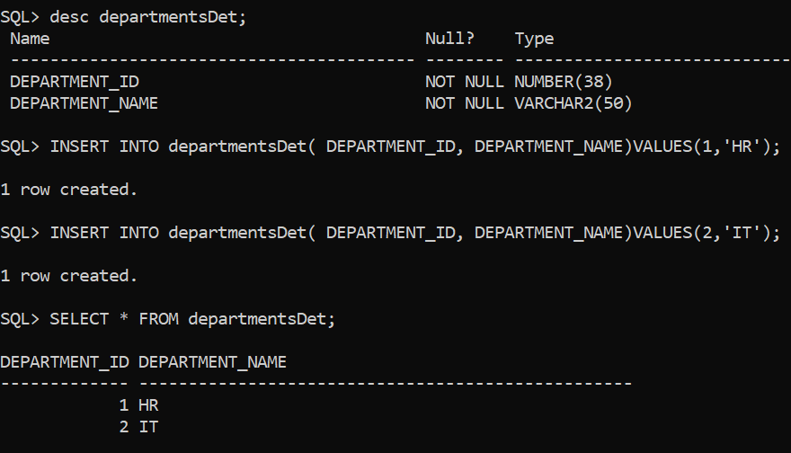

**Unique:**

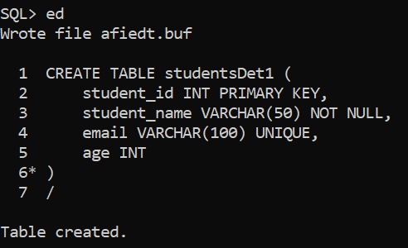

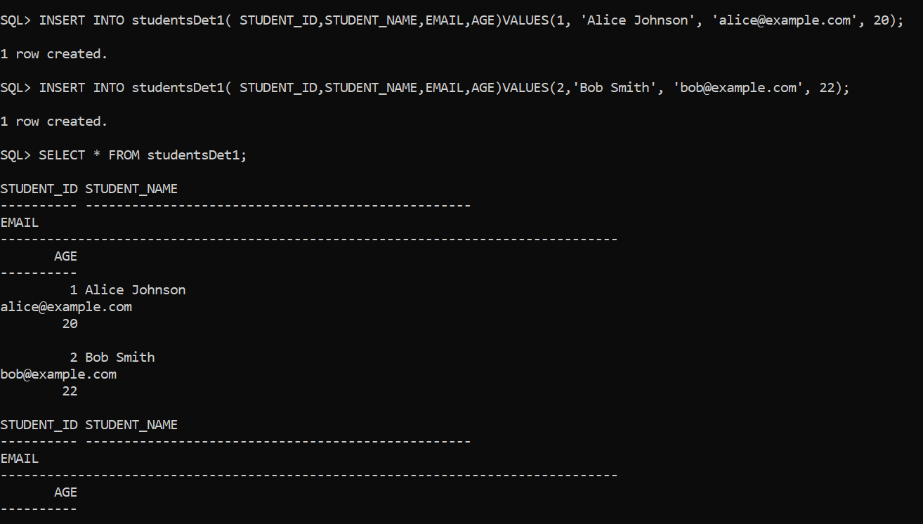

**NotNull:**

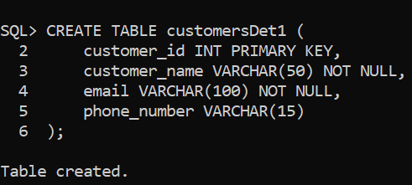

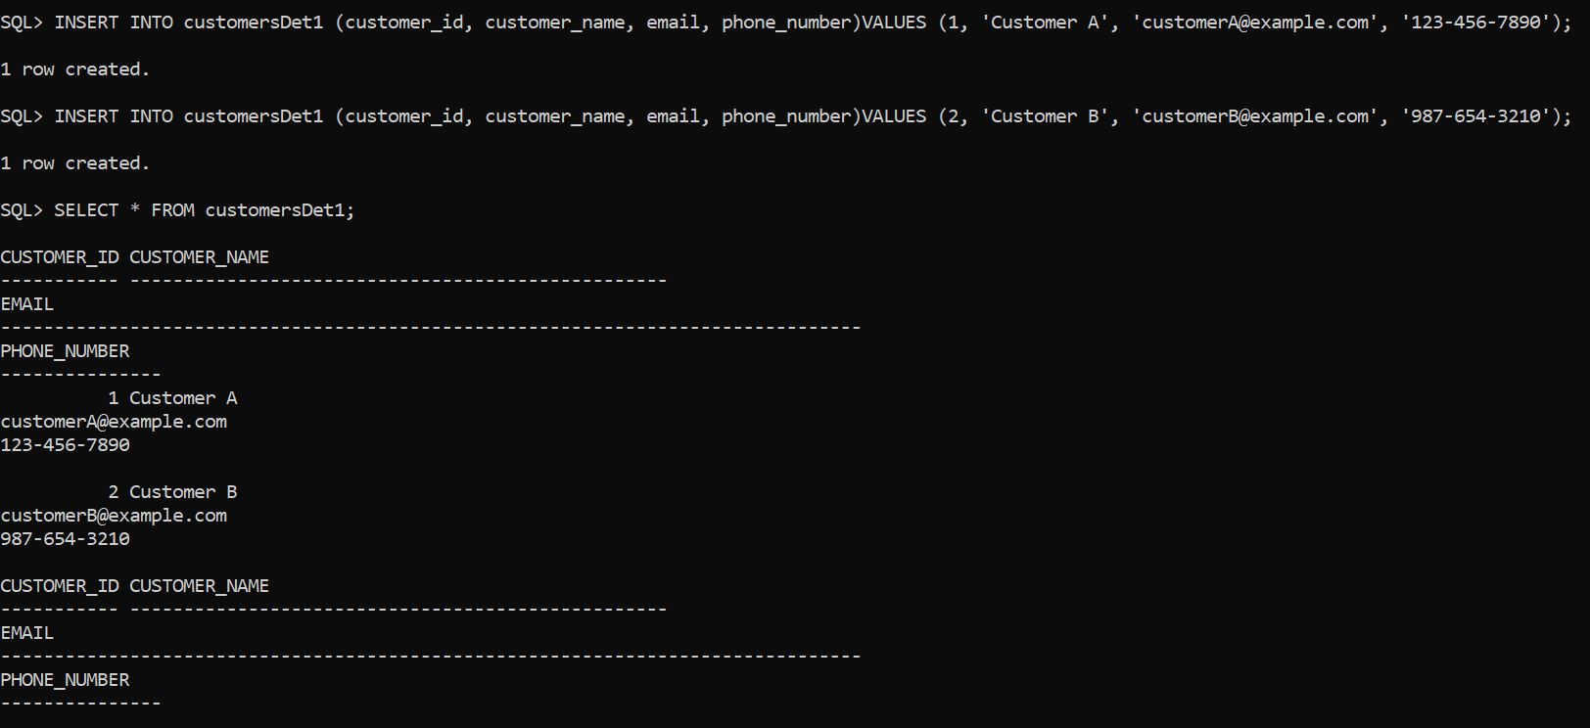

**Check:**

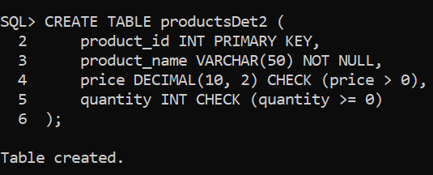

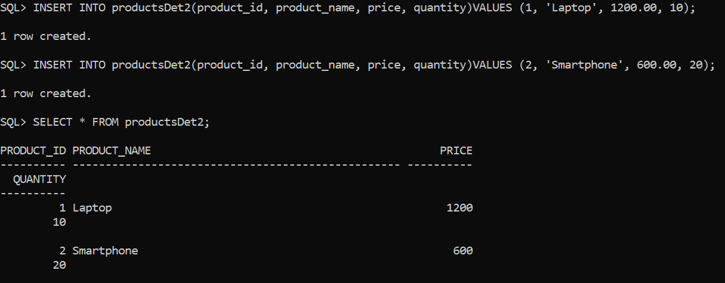

**Default:**

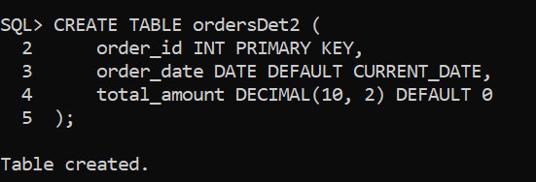

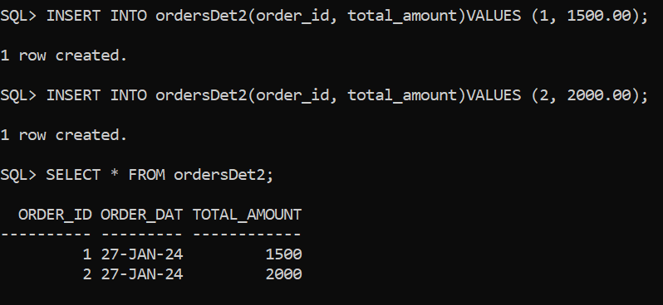

1. **Write a PL/SQL program for calculating the factorial of a given number.**

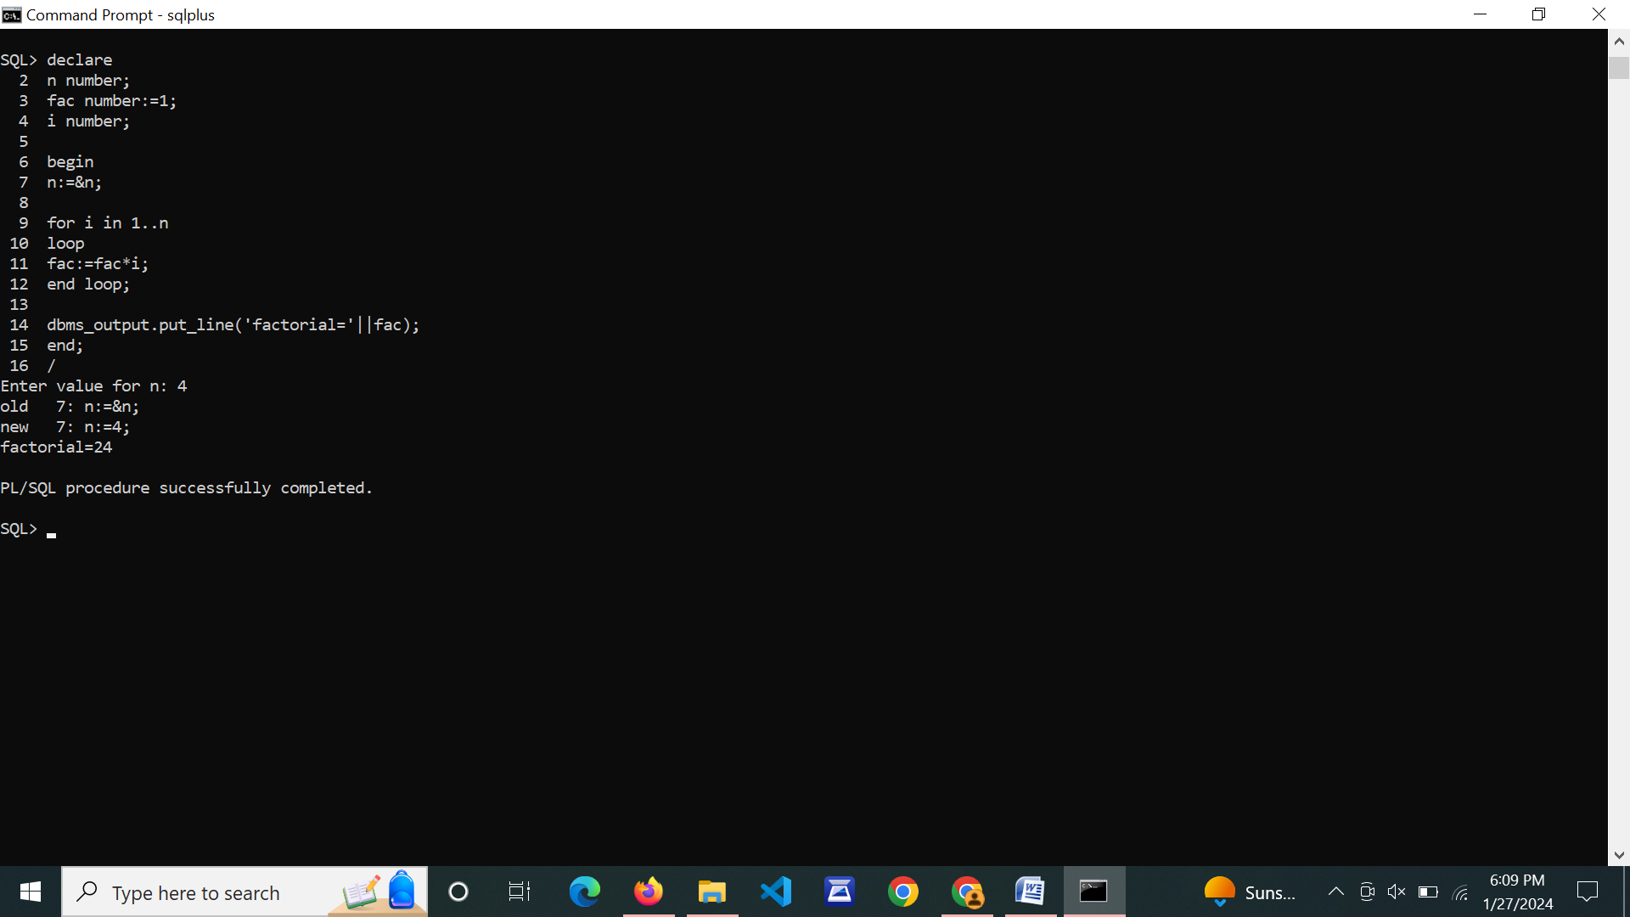

1. **Write a PL/SQL program for finding the given number is prime number or not.**

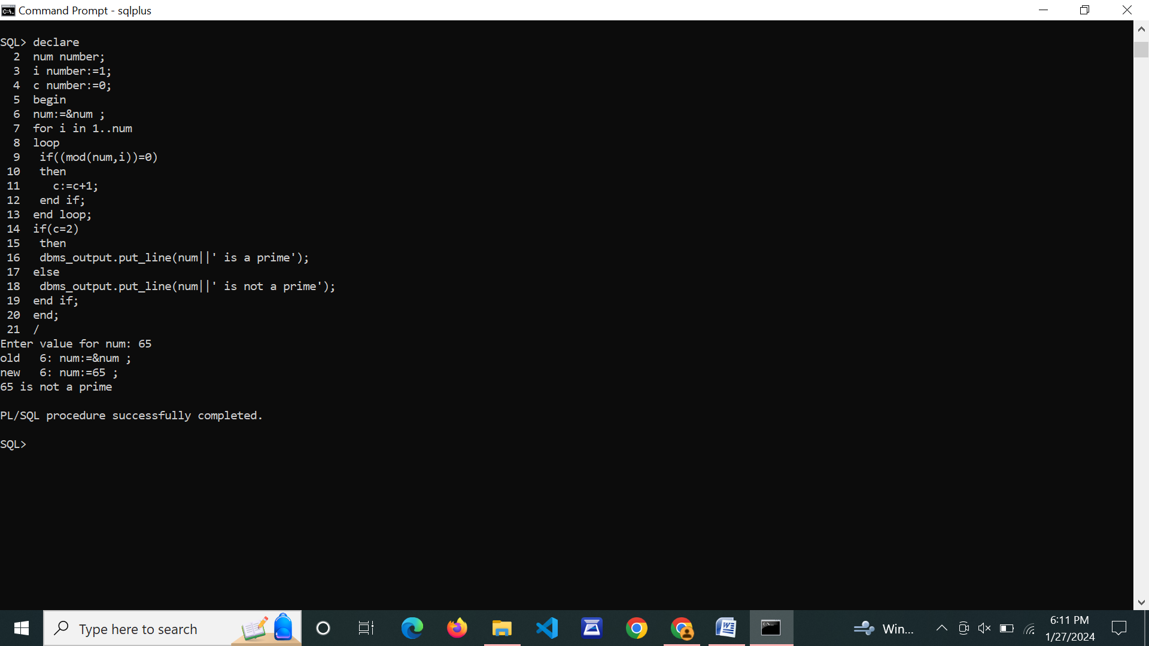

1. **Write a PL/SQL program for displaying the Fibonacci series up to an integer.**

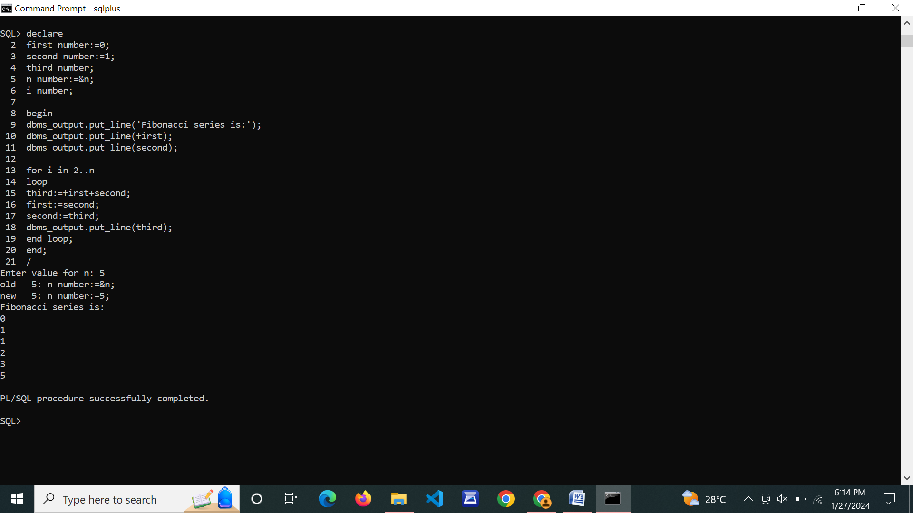

1. **Write PL/SQL program to implement Stored Procedure on table.**

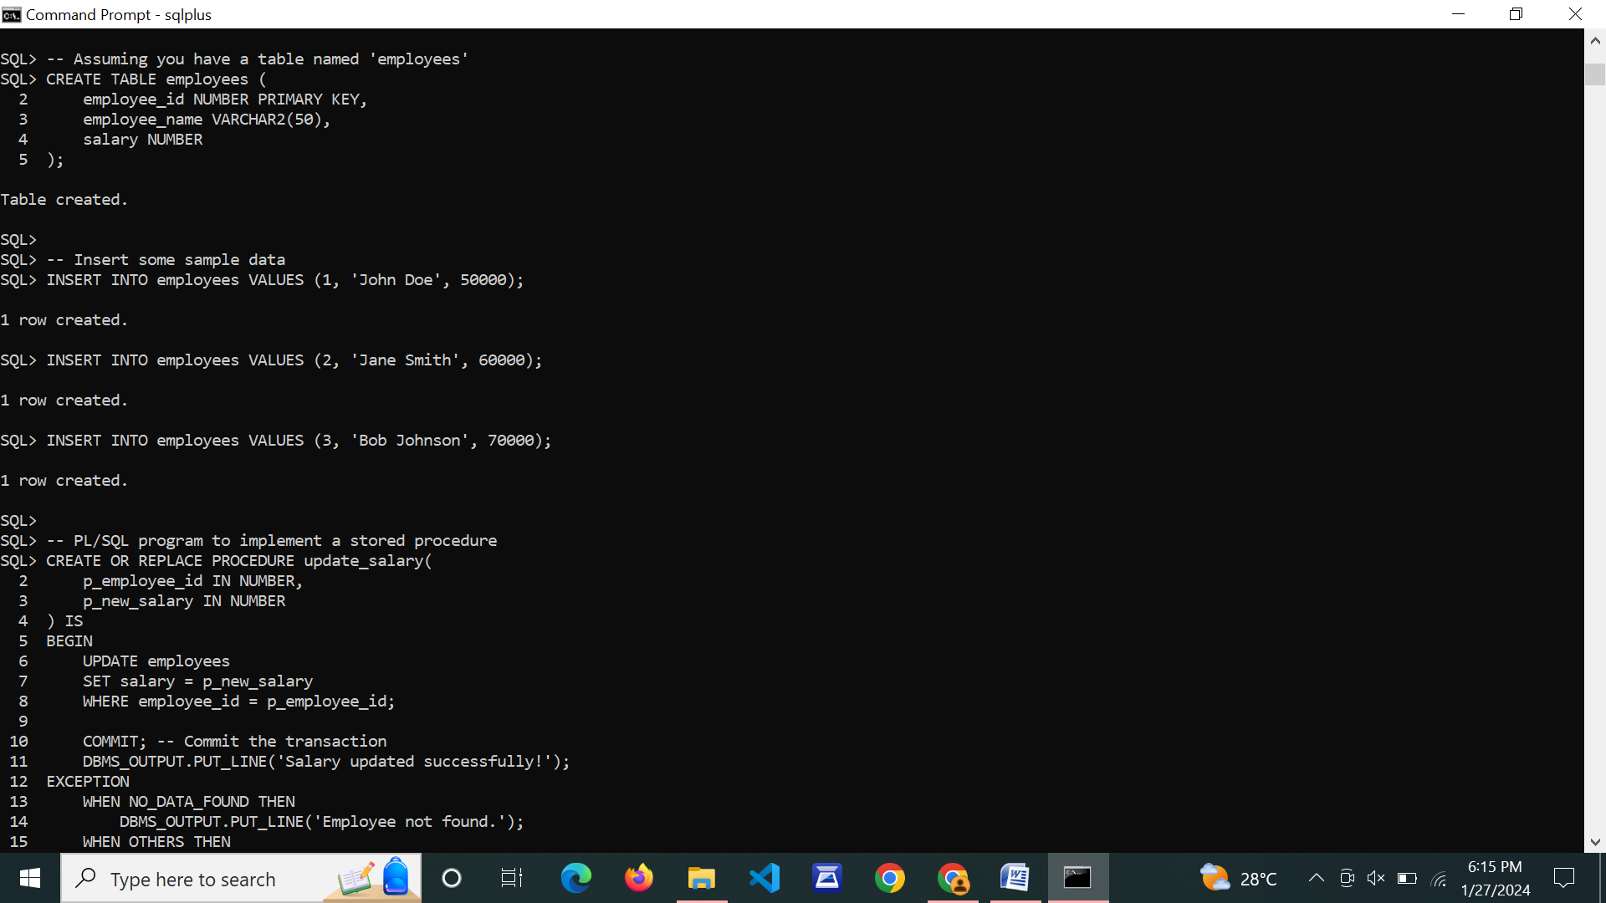

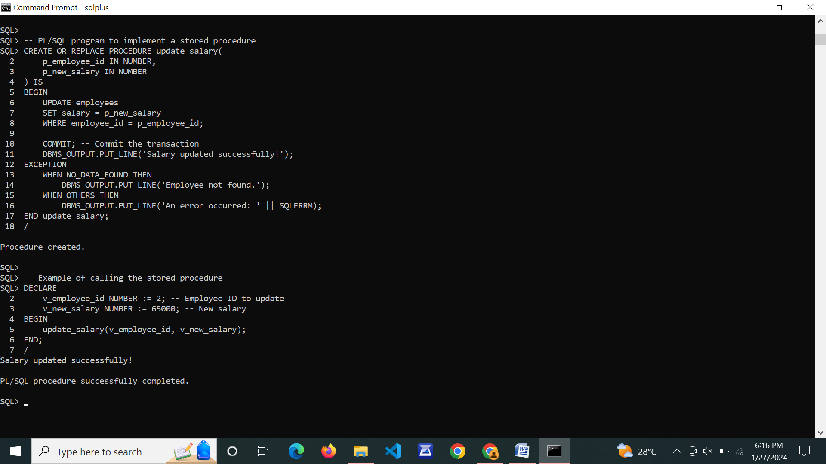

1. **Write PL/SQL program to implement Stored Function on table.**

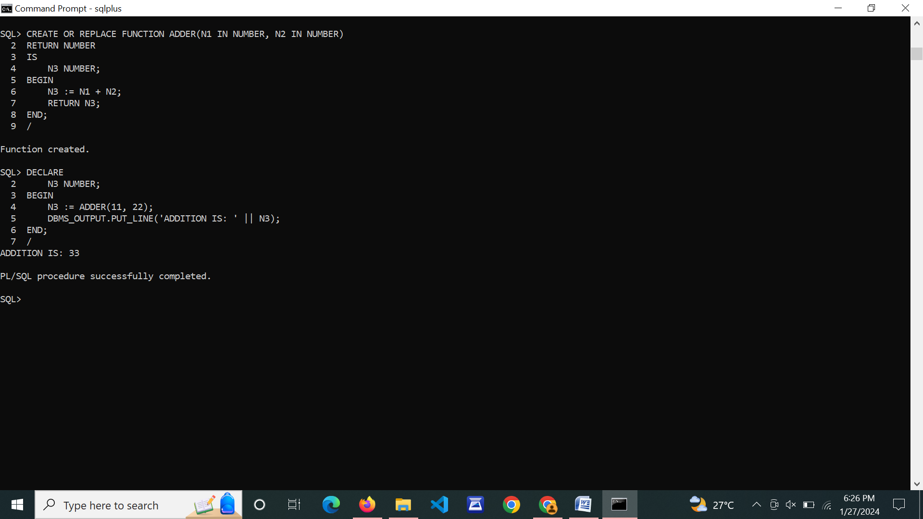

1. **Write PL/SQL program to implement Trigger on table.**

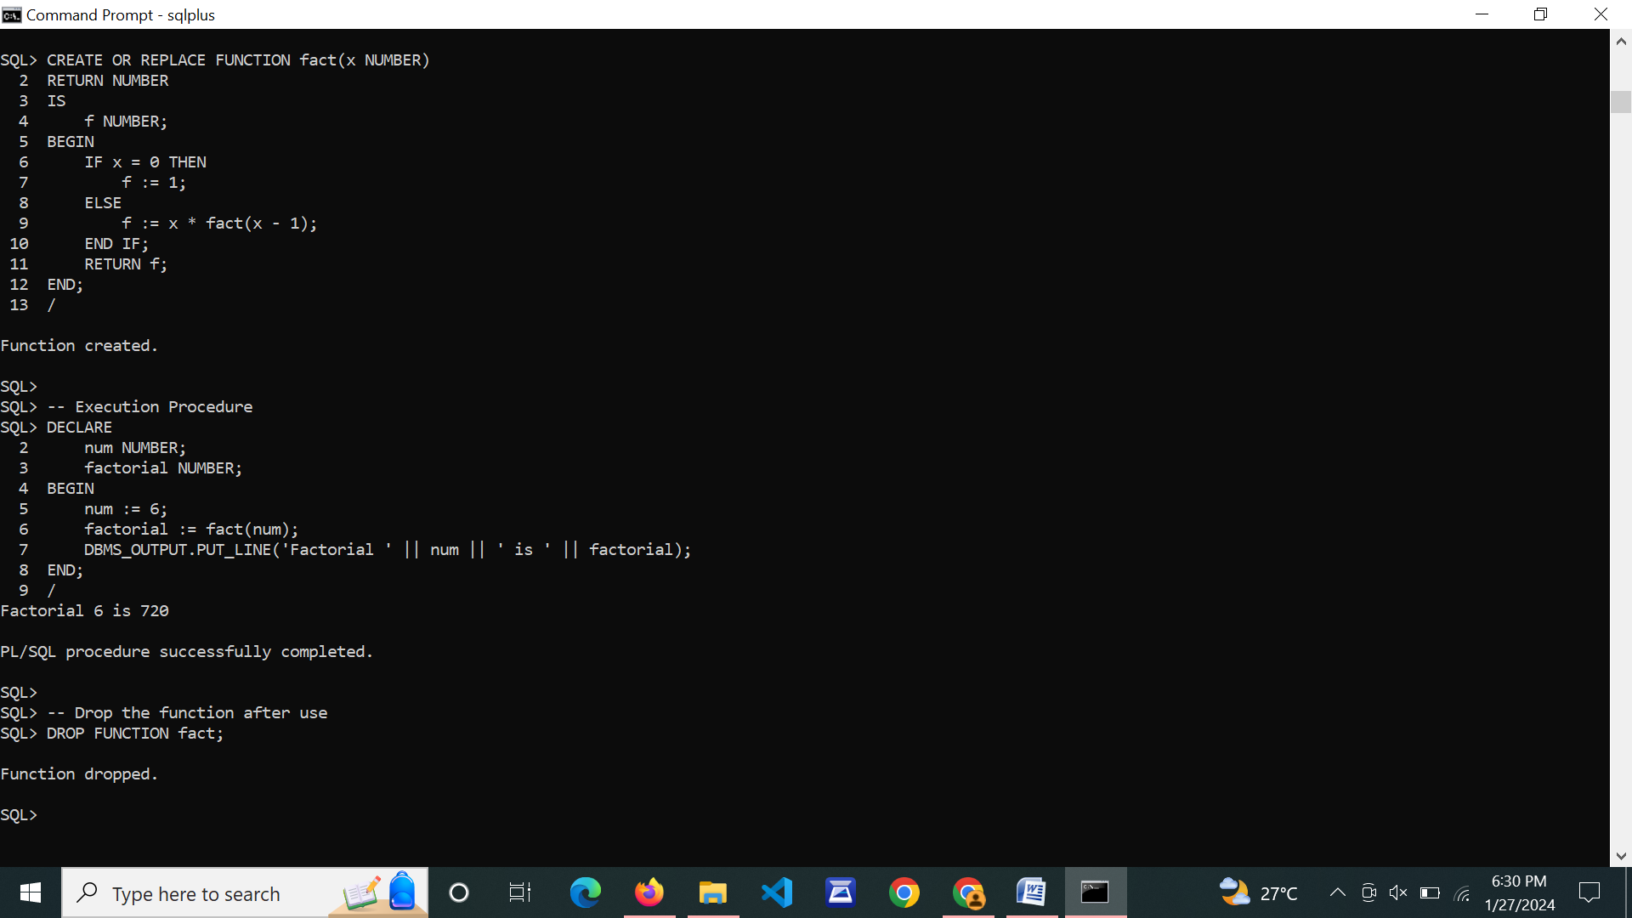

1. **Write PL/SQL program to implement Cursor on table.**

